It Practical File 2022

**Course Name: BSc(H) Computer Science Semester: 5th semester**

**Subject: IT LAB**

1. **Display your systems IP Address, Subnet mask using ipconfig, and find out the network address and the maximum number of systems possible on your network and range of IP addresses available to these systems.**

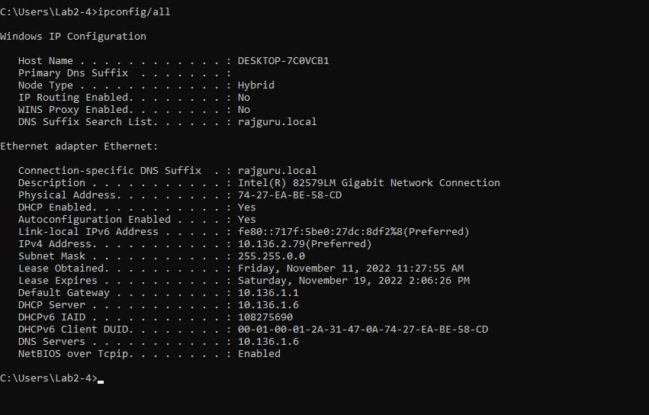

**Given:**

**IP Address** 10.136.2.79 [00001010.10001000.00000010.01001111 **(in binary)]**

**Subnet mask** 255.0.0.0 [11111111.00000000.00000000.00000000 **(in binary)]**

##### Now, Network Address = IP Address + Subnet Mask

i.e., **Network Address =** 10.136.2.79 + 255.0.0.0

##### = 10.0.0.0

Since, the IP Address belongs to **Class A,** therefore, it requires ***first Octet***

for **Network Address** and next **three octets** for the **Host Address.**

Thus, the 2nd,3rd,4rth Octets containing 24-bits will provide 224 **different addresses** for hosts.

But, two addresses, one for *the host of the network*, and the other for *the DBA of the Network*, are reserved and cannot be used.

##### => Maximum number of hosts possible = 16777216- 2 = 16777214

**=> Range of IP Addresses available:**

**From** 10.136.2.1 **To** 10.136.2.254

# With help of ping, check if you are connected to other systems of your network and find the route to connect to that system using tracert. List all the processes which are using ports for TCP protocol.]

## Ping command

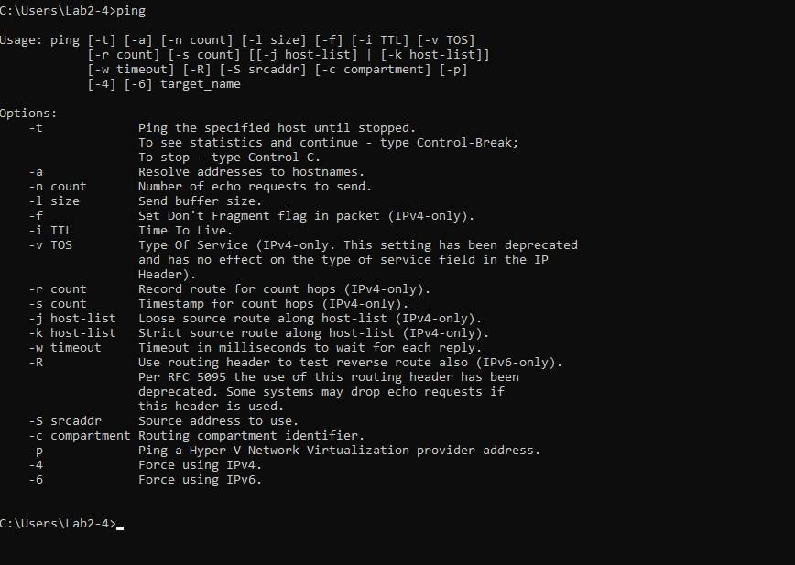

* + 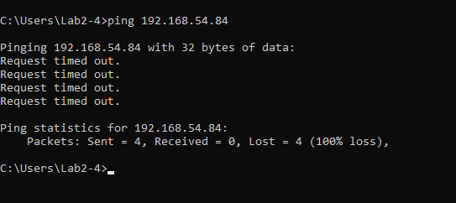**ping 192.168.29.196**

## netstat -ano

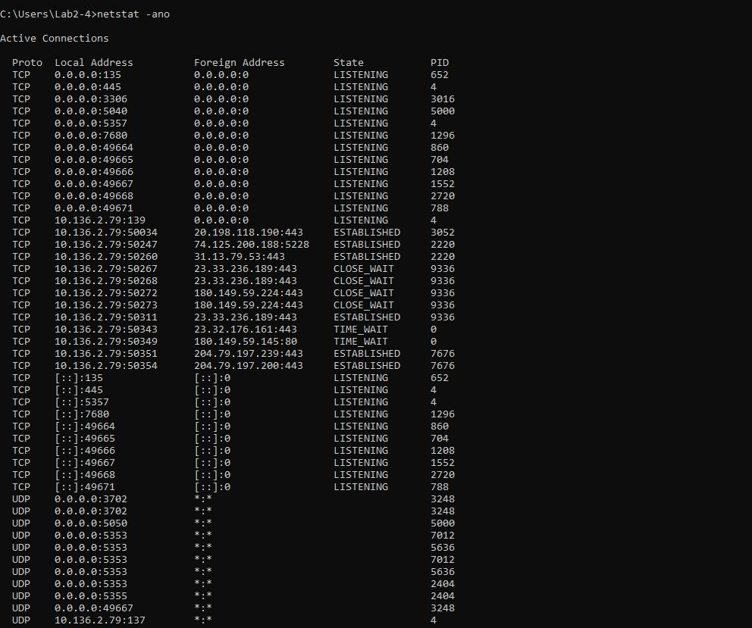

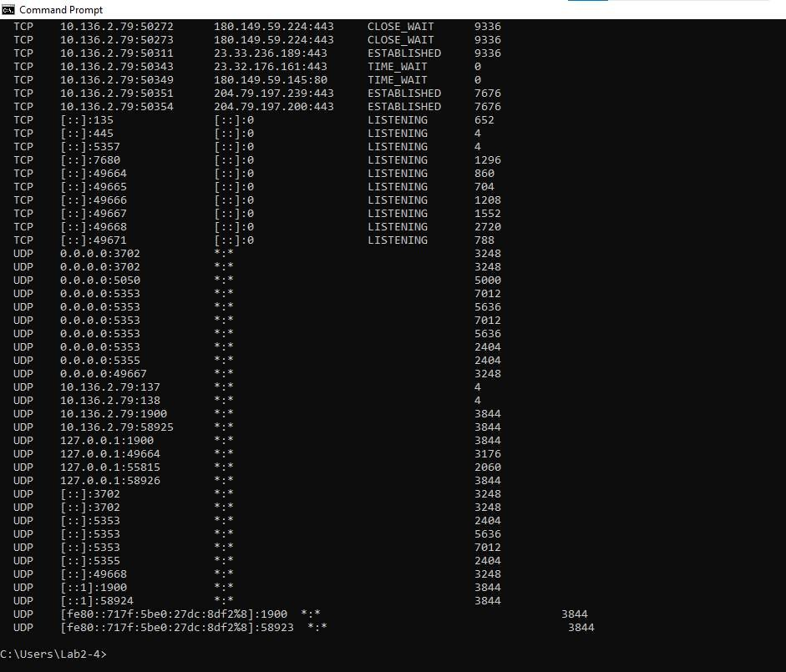

1. **Create an HTML page that shows information about you, your course, hobbies, address, and your plans. Use CSS for styling of HTML page so that looks nice.**

**P3.html**

<!DOCTYPE html>

<html>

<head>

<title>ABOUT ME</title>

<link rel="stylesheet" href="styles.css">

</head>

<body>

<header>

<div class="main">

<ul>

<li><b><a href="about.html">ABOUTS</a></b></li>

<li><b><a href="address.html">COURSE</a></b></li>

<li><b><a href="hobbies.html">HOBBIES</a></b></li>

<li><b><a href="address.html">ADDRESS

</a></b></li>

<li><b><a href="plans.html">PLANS</a></b></li>

</ul>

</div>

<div class=""title">

<style>h1{text-align: center;}</style>

<h1><i>HELLO,I AM MEENAKSHI</i></h1>

</div>

</header>

</body>

<html>

# Hobbies.html

<!DOCTYPE html>

<html>

<head>

<title>HOBBIES</title>

</head>

<body>

<style>

body {

background-image: url("img/obby.jpg"); background-repeat: no-repeat; background-size: cover;

}

</style>

<div class=" title">

<h1><i>My Hobbies are:</i></h1>

</div>

<span style="font-size: 20px;font-family: 'Segoe UI', Tahoma, Geneva, Verdana, sans-serif;">

<p> Playing Badminton<br><br>Evening Walks<br><br>Listening and Singing Songs<br><br>Reading Novels:)<br><br>Coding<br><br> Most Importantly Trying new tasty tasty dishes:)

</p>

</span>

</body>

<html>

# Course.html

**<!DOCTYPE html>**

<html>

<head>

<title>COURSE</title>

</head>

<body>

<header>

<style>

body {

background-image: url("img/course.jpg"); background-repeat: no-repeat;

background-size: cover;

}

</style>

<div class="" title">

<h1><i>My Course</i>

</div>

</h1>

<span style="font-size: 20px">

<p>Hello<br><br>I am a 3rd year student of Shahhed Rajguru college of Applied Sciences for women.<br><br>Current I am pursuing my Bsc (Hons) in CS. I also have a keen interest in android and web development.<br><br>I have also done an App development course from tech era<br><br>I have built a desktop application as summer project on

"Library Management System".<br><br>I like to explore new things and thank you for your time u give for reading my portfolio :)</p>

</span>

</div>

</header>

</body>

<html>

# Address.html

**<!DOCTYPE html>**

<html>

<head>

<title>Address</title>

</head>

<body>

<header>

<style>

body{

background-image: url("img/ddress.jpg"); background-repeat: no-repeat;

background-size: cover;

}

</style>

<div class=""title">

<span style="font-size: 50px">

<h1><i>My Address</i><h1></h1></span>

<span style="font-size: 30px">

<li>I was born in Haryana,but I live mostly in Kanpur,UP.<br><br>I am living in College Hostel,Noida:)</li>

</span>

</div>

</header>

</body>

<html>

# About.html

**<!DOCTYPE html>**

<html>

<head>

<title>ABOUT ME</title>

</head>

<body>

<header>

<style>

body{

background-image: url("img/about.jpg"); background-repeat: no-repeat; background-size: cover;

}

.title{

font-family: 'Segoe UI', Tahoma, Geneva, Verdana, sans-serif; font-size: medium;

}

</style>

<div class=""title">

<h1><i>About me<br><br>Hello :)<br><br>I am Meenakshi<br><br>I want to be a software Engineer,current pursuing Bsc(ons) CS<br><br>Wish you a good day!!!!</h1>

</div>

</header>

</body>

<html>

# Plans

**<!DOCTYPE html>**

<html>

<head>

<title>PLANS</title>

</head>

<body>

<header>

<style>

body {

background-image: url("img/lan.jpg"); background-repeat: no-repeat; background-size: cover;

}

</style>

<div class="" title">

<span style="font-size: 13px">

<h1><i>MY LIFE GOALS:-</i></h1>

</span>

<span style="font-size: 26px">

<p><i>TO BE A SOFTWARE ENGINEER<br><br>TO COMPOSE MY OWN SONGS<br><br>TO TAKE MY PARENTS ON A WORLD

TOUR<br><br>TO BE A RESIDENT IN SEOUL,SOUTH KOREA:)<br><br>To be a part of purple Ocean one day.<br><br>There are many more but if i wrte all,u will get bored':|</i></p>

</span>

</div>

</header>

</body>

<html>

# Output

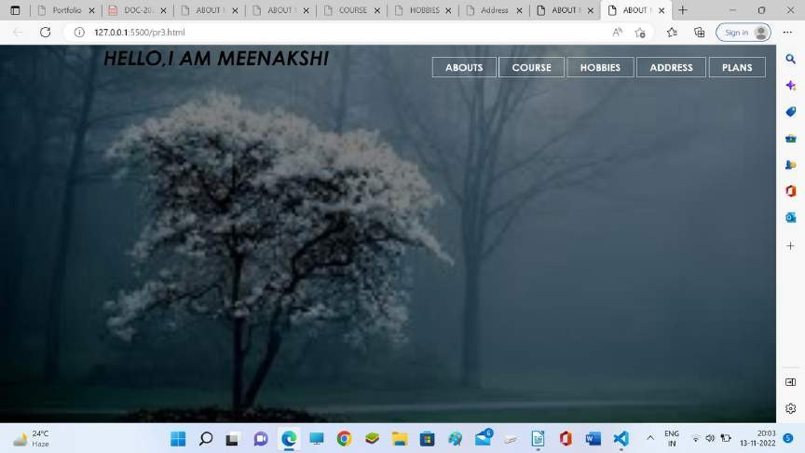

**On clicking abouts**

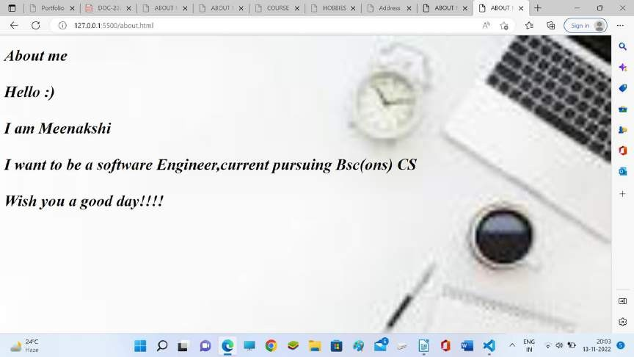

**on clicking course**

**on clicking hobbies**

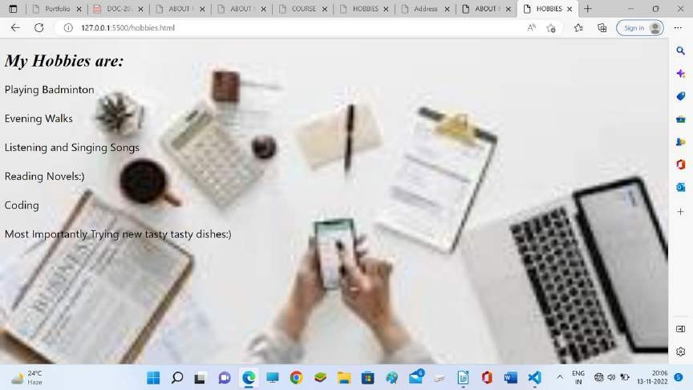

**on clicling address**

**on clicking plans**

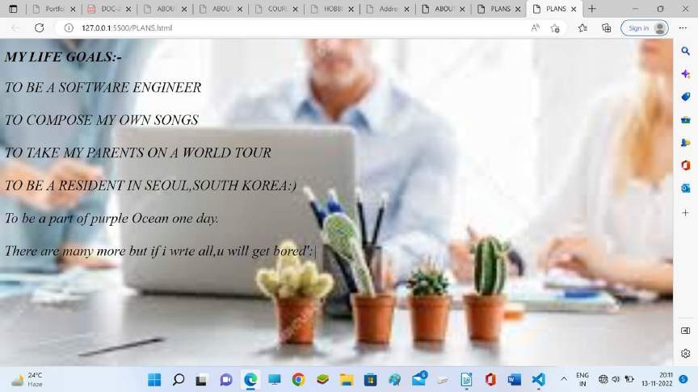

## Create an HTML page with the sole purpose to show multiplication tables of 2 to 10 (row-wise) created by JavaScript. Initially, the page is blank. With help of setInterval function print a row every 5 seconds in different colors and increasing font size.

**P4.html**

**<!DOCTYPE html>**

<html lang="en">

<head>

<meta charset="UTF-8">

<meta http-equiv="X-UA-Compatible" content="IE=edge">

<meta name="viewport" content="width=device-width, initial-scale=1.0">

<link rel="stylesheet" href="base.css">

<title>MULTIPLICATION TABLE</title>

<style>

body {

background-color: #a9deef92;

}

.button2 {

background-color: white;

/* Green */ border: none; color: white; padding: 16px 32px; text-align: center;

text-decoration: none; display: inline-block; margin: 4px 4px; transition-duration: 0.4s; cursor: pointer;

border-radius: 10px;

}

</style>

</head>

<body>

<div id=timer></div>

<script>

function text_font_size(i) { return 10 + i + "px";

}

function text_color(i) {

color_array = ['#C0392B', '#5DADE2', '#76448A', '#BA4A00', '#2471A3', '#1ABC9C', '#F4D03F', '#B9770E', '#A04000', '#34495E']

return color_array[i - 1]

}

function display(i) {

timer = document.getElementById('timer')

var table_row = document.createElement("button"); table_row.classList.add('button2') table_row.style.width = 1200 + "px"; table_row.style.fontSize = text_font_size(i); table_row.style.color = text_color(i);

for (var k = 1; k <= 10; k++) {

var row_text = document.createTextNode(i + " x " + k + " = " + i * k + " "); table_row.appendChild(row_text);

timer.appendChild(table_row)

}

}

function timer_display() {

var refresh = 5000; // Refresh rate in milliseconds var i = 2;

myvar = setInterval(function () { if (i == 11)

clearInterval(myvar) else

display(i++)

}, refresh)

}

timer_display()

</script>

</body>

</html>

<link rel="stylesheet" href="base.css">

</head>

<body>

<div id=timer></div>

</body>

</html>

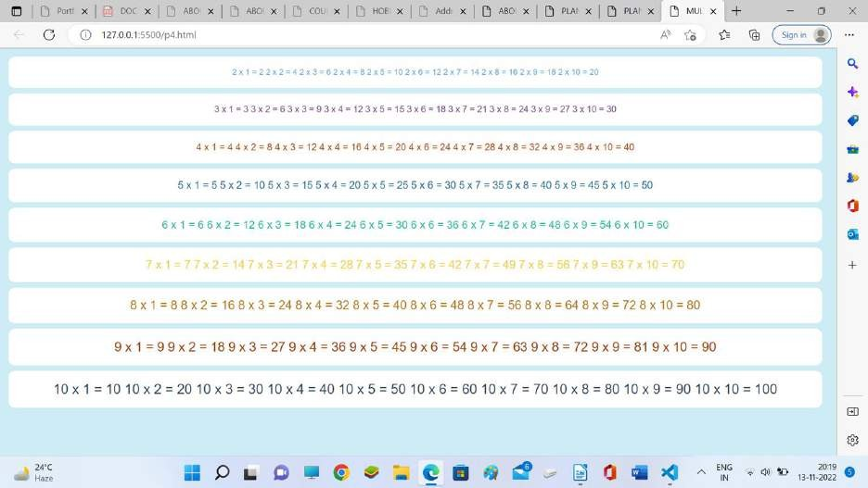

# Output

1. **Create an HTML page with a paragraph written on it and under which 9 buttons are placed in a 3X3 grid. The first row is for buttons labeled with colors names Red, Green, and Blue, the second row with**

**numbers 10, 20, 30, and the third row with different font names. Click event of each of the buttons should make the appropriate change in the style of paragraph.**

**P5.html**

#### <!DOCTYPE HTML>

<html>

<head><title>IT PRACTICAL-5</title>

<style>

.grid-container { display: grid;

grid-template-columns: auto auto auto; background-color: #2196F3;

padding: 10px;

}

.grid-item {

background-color: rgba(255, 255, 255, 0.8);

border: 1px solid rgba(0, 0, 0, 0.8); padding: 20px;

font-size: 30px; text-align: center;

}

</style>

</head>

<body>

<p id="p1"> Parakeets comprise about 115 species of birds that are seed-eating parrots of small size, slender build, and long, tapering tails.[2] The Australian budgerigar, also known as "budgie", Melopsittacus undulatus, is probably the most common parakeet. It was first described by zoologists in 1891. It is the most popular species of parakeet kept as a pet in North America and Europe.A rose-ringed parakeet (Psittacula krameri).The term "grass parakeet" (or grasskeet) refers to many small Australian parakeets native to grasslands such as the genus Neophema and the princess parrot. The Australian rosellas are also parakeets. Many of the smaller, long-tailed species of lories may be referred to as "lorikeets". The vernacular name ring-necked parakeet (not to be confused with the Australian ringneck) refers to a species of the genus Psittacula native to Africa and Asia that is popular as a pet and has become feral in many cities outside its natural range.In aviculture, the term "conure" is used for small to medium-sized parakeets of the genera Aratinga, Pyrrhura, and a few other genera of the tribe Arini, which are mainly endemic to South America. As they are not all from one genus, taxonomists tend to avoid the term. Other South American species commonly called parakeets include the genus Brotogeris parakeets, the monk parakeet, and lineolated parakeets, although lineolateds have short tails.</p>

<div class="grid-container">

<div class="grid-item" input type="button" id="red" onclick="changecolor('red')">RED</div>

<div class="grid-item" input type="button" id="blue" onclick="changecolor('blue')">BLUE</div>

<div class="grid-item" input type="button" id="green" onclick="changecolor('green')">GREEN</div>

<div class="grid-item" input type="button" id="10" onclick="dosize('10px')">10</div>

<div class="grid-item" input type="button" id="15" onclick="dosize('15px')">15</div>

<div class="grid-item" input type="button" id="20" onclick="dosize('20px')">20</div>

<div class="grid-item" input type="button" id="f1" onclick="changefont('calibri')">CALIBRI</div>

<div class="grid-item" input type="button" id="f2" onclick="changefont('cursive')">CURSIVE</div>

<div class="grid-item" input type="button" id="f3" onclick="changefont('arial')">ARIAL</div>

<script>

function changecolor(color){

document.getElementById('p1').style.color = color;

}

function dosize(size){ document.body.style.fontSize = size;

}

function changefont(font){ document.body.style.fontFamily = font;

}

</script>

</body>

</html>

# Output

**On clicking red**

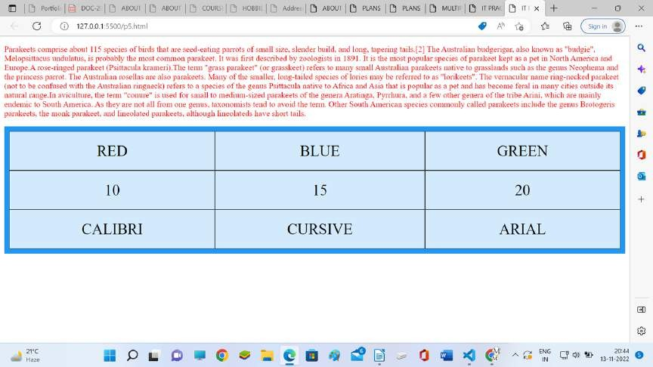

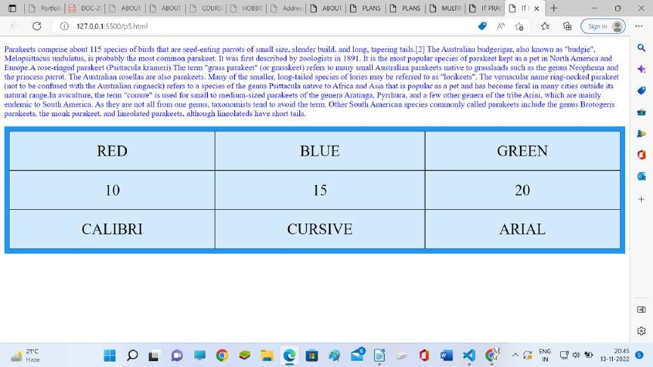**on clicking blue**

**on clicking green**

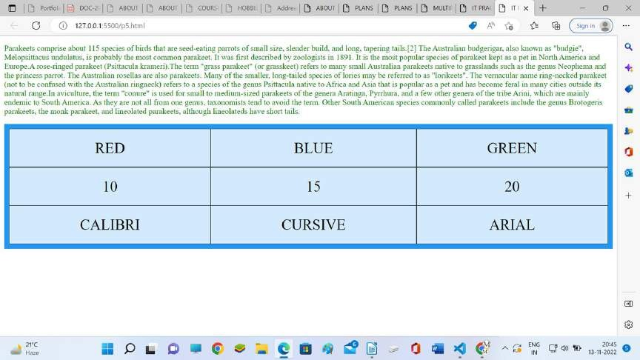

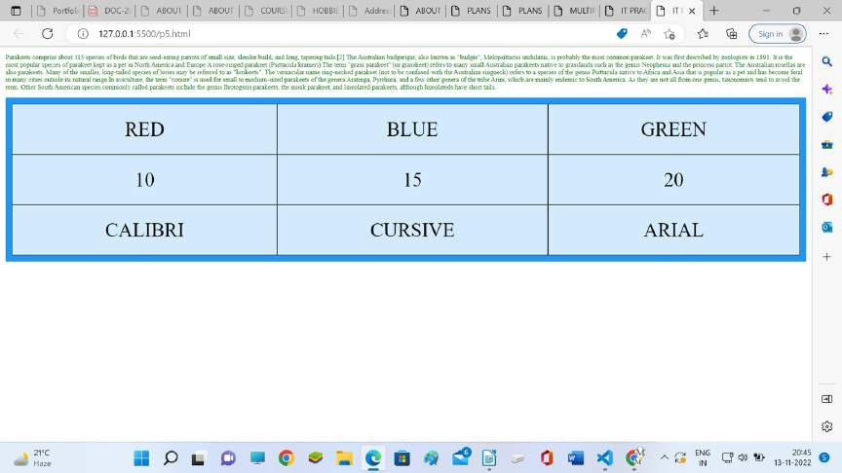**on clicking 10**

**on clicking 15**

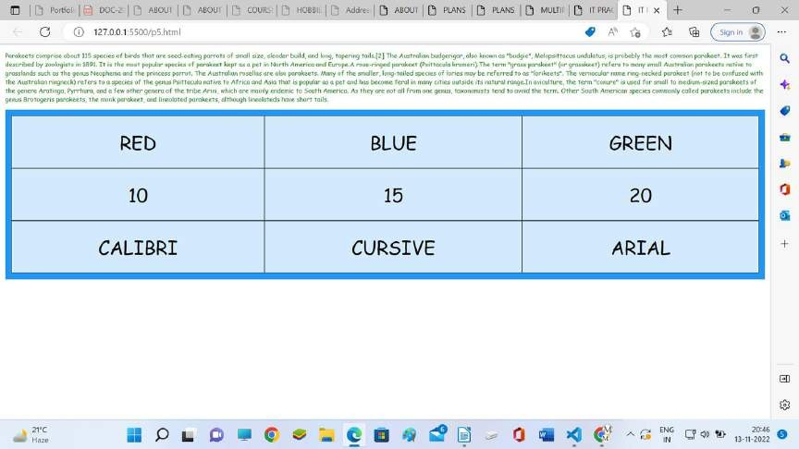

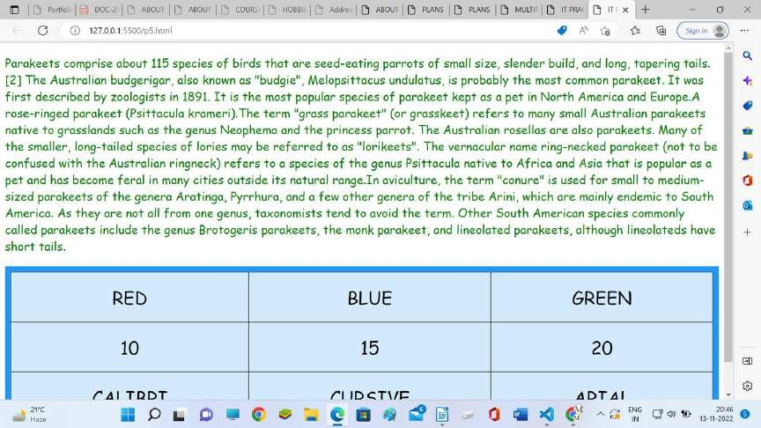**on clicking 20**

**on clicking calibri**

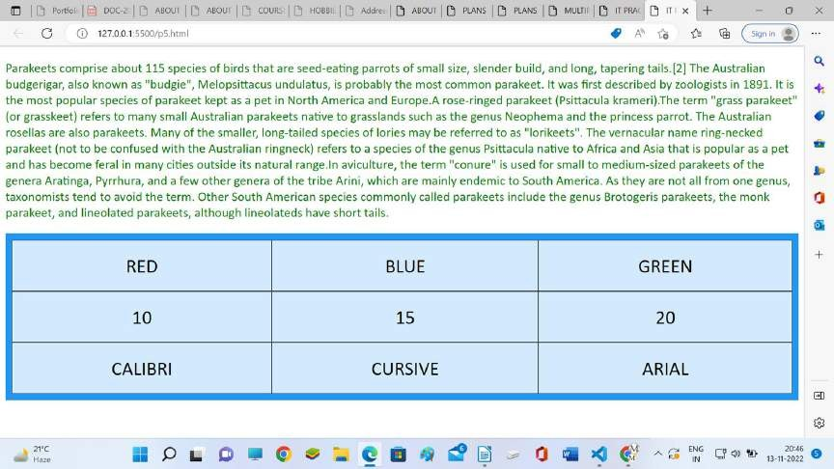

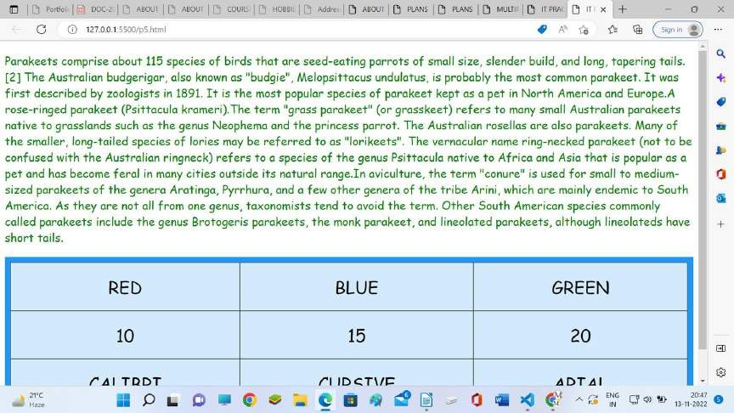**on clicking cursive**

**on clicking arial**

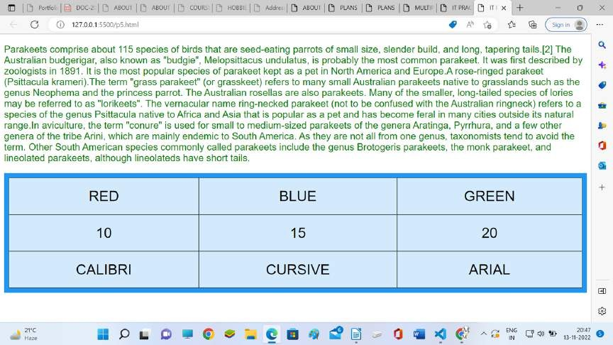

## Create a form that takes data about a pet. The form must be well designed and should accept the pet’s name, age, weight, type, and what it likes most. At the submission of this form create a Pet object in JavaScript filled with these values and log that object and equivalent JSON on the console.

<!DOCTYPE html>

<html>

<head>

<style>

label, input, button {

border: 0;

margin-bottom: 3px; display: block; width: 100%;

}

.common_box_body { padding: 15px;

border: 12px solid #28BAA2;

border-color: #28BAA2; border-radius: 15px; margin-top: 10px; background: #d4edda;

}

</style>

</head>

<body>

<div class="common_box_body test">

<h2> Pet Registration</h2>

<h3 id="po">Input Array Elements</h3>

<form action="#" name="registration" id="registration">

<label for="petname">Pet Name</label>

<input type="text" name="array[]" id="petname" placeholder="Mitthu"><br>

<label for="Age">Age</label>

<input type="number" name="array[]" id="age" placeholder="age"><br>

<label for="weight">Weight</label>

<input type="number" name="array[]" id="weight" placeholder=""><br>

<label for="Type">Type</label>

<input type="text" name="array[]" id="type" placeholder=""><br>

Select Likes(s): <br>

<input type="checkbox" id="Likes" name="Playing" value="Playing">

<label for="like1">Playing<label><br>

<input type="checkbox" id="Likes" name="Sleeping"

value="Sleeping">

value="Eating">

</form>

<br>

</div>

<label for="like2"> Sleeping</label><br>

<input type="checkbox" id="Eating" name="Eating"

<label for="like3"> Eating</label><br>

<button type="button" id="submit" name="button"> Submit

</button>

<div id="showTable"></div>

<script src="jquery-3.6.1.min.js"></script>

<script>

$(document).ready(function () {

$("#submit").click(function () { pname = $("#petname").val();

age = $("#age").val();

weight = $("#weight").val();

type = $("#type").val(); const likes = [];

$("input[type=checkbox]:checked").each(function () { likes.push($(this).val());

});

function pet(pname, age, weight, type, likes) { this.pname = pname;

this.age = age; this.weight = weight; this.type = type; this.likes = likes;

}

var pet1 = new pet(pname, age, weight, type, likes); console.log(pet1)

console.log(JSON. stringify(pet1));

//Read Object

}

);

});

</script>

<script src="jquery-3.6.1.min.js"></script>

</body>

</html>

# Output

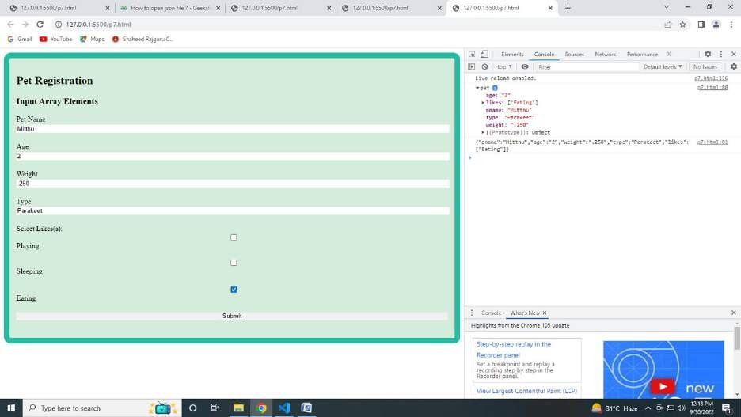

1. **Store JSON data of few pets that you created in previous practical in a JSON file (copy from console output of previous program to a**

**.json file). Using AJAX, load data from the file and display it in a presentable way using HTML and CSS.**

**P7.html**

**<!DOCTYPE html>**

<html>

<head>

<title>Read data from External JSON file using JavaScript</title>

<style>

body {

background-color: lavender;

}

h1 {

text-align: center; color: brown;

}

div {

font: 17px 'Calibri';

}

table, th,

td {

border: solid 2px black; background-color: beige; border-collapse: collapse; padding: 2px 3px;

text-align: center;

font: 200 20px Times New Roman; color: navy;

margin: auto;

}

th {

font-weight: bold; color: black;

}

</style>

</head>

<body>

<h1>

PET DETAILS

</h1>

<div id='showTable'></div>

<script>

// Create XMLHttpRequest object. var oXHR = new XMLHttpRequest();

// Initiate request. oXHR.onreadystatechange = reportStatus;

oXHR.open("GET", "data.json", true); // get json file. oXHR.send();

function reportStatus() {

if (oXHR.readyState == 4) // Check if request is complete.

{

// Create an HTML table using a response from the server. displayData(this.responseText);

}

}

// Create an HTML table using the JSON data.

function displayData(jsonData) { var arrData = [];

arrData = JSON.parse(jsonData); // Convert JSON to array. var col = [];

for (var i = 0; i < arrData.length; i++) { for (var key in arrData[i]) {

if (col.indexOf(key) === -1) { col.push(key);

}

}

}

// Create a dynamic table.

var table = document.createElement("table");

// Create table header.

var tr = table.insertRow(-1); // Table row. for (var i = 0; i < col.length; i++) {

var th = document.createElement("th"); // Table header. th.innerHTML = col[i];

tr.appendChild(th);

}

// Add JSON to the table rows.

for (var i = 0; i < arrData.length; i++) { tr = table.insertRow(-1);

for (var j = 0; j < col.length; j++) { var tabCell = tr.insertCell(-1); tabCell.innerHTML = arrData[i][col[j]];

}

}

// Finally, add the dynamic table to a container.

var divContainer = document.getElementById("showTable"); divContainer.innerHTML = ""; divContainer.appendChild(table);

};

</script>

<script src="jquery-3.6.1.min.js"></script>

</body>

</html>

# data.json

**[**

{

"Name": "Tommy",

"Age": "2 months",

"Weight": "5 kg",

"Type": "Dog",

"Likes": "Playing and Eating"

},

{

"Name": "Jenny",

"Age": "3 months",

"Weight": "3 kg",

"Type": "Cat", "Likes": "Playing"

},

{

"Name": "Bunny",

"Age": "5 months",

"Weight": "4 kg",

"Type": "Rabbit", "Likes": "Carrots"

},

{

"Name": "Goldy",

"Age": "1 month",

"Weight": "1 kg",

"Type": "Fish", "Likes": "Swimming"

}

]

# Output

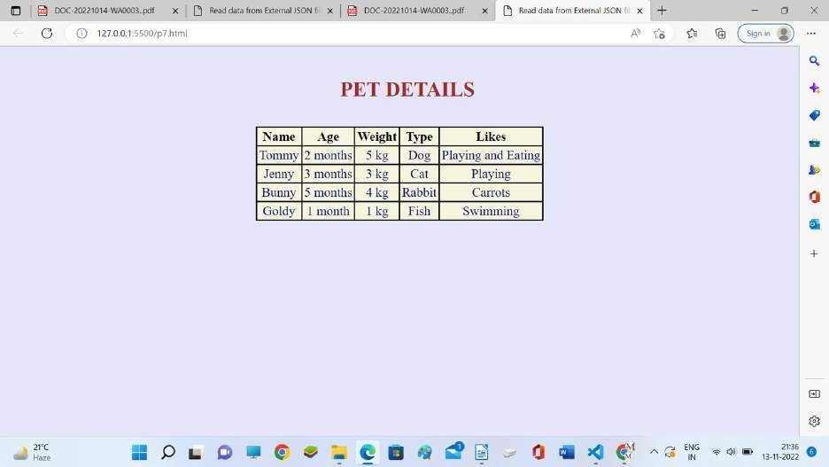

##### Create a plain HTML page for B.Sc. Hons CS course, mentioning details like fee, eligibility criteria, papers with names and credits, and future possibilities after the course. A button for styling should be there at bottom of the page. On clicking on this button JavaScript should redesign the complete page using jQuery in a nice presentable way.

<!DOCTYPE html>

<html lang="en">

<head>

<meta charset="UTF-8">

<meta http-equiv="X-UA-Compatible" content="IE=edge">

<meta name="viewport" content="width=device-width, initial-scale=1.0">

<title>BSc (Hons.) Computer Science</title>

<link rel="stylesheet" href="./prog8.css">

<script

src="https://code.jquery.com/jquery-3.6.0.min.js"></script>

<script rel="text/javascript" src="course.js"></script>

<link rel="preconnect" href="https://fonts.gstatic.com">

<link href=["https://fonts.googleapis.com/css2?family=Poppins:wght@300;400;60](https://fonts.googleapis.com/css2?family=Poppins%3Awght%40300%3B400%3B60) 0&display=swap" rel="stylesheet">

<link rel="preconnect" href="https://fonts.googleapis.com">

<link

href="https://fonts.googleapis.com/css2?family=Roboto&display=swap" rel="stylesheet">

</head>

<body>

<header class="course_header">

<div class="layer"></div>

<div class="header_text">

<h1 class="head_">SHAHEED RAJGURU COLLEGE OF APPLIED SCIENCES FOR WOMEN, UNIVERSITY OF DELHI</h1>

<h2 class="head_">BSc (Hons.) Computer Science</h2>

<div class="nav-wrapper">

<ul class="navbar">

<li class="nav_item"><a href="#about">About</a></li>

<li class="nav_item"><a href="#fees">Fee</a></li>

<li class="nav_item"><ahref="#eligibility">Eligibility Criteria</a></li>

<li class="nav_item"><a

href="#course-structure">Course Structure</a></li>

<li class="nav_item"></li>

</ul>

</div>

</div>

</header>

<div id="about" class="container">

<h1 class="headings">About</h1>

<div class="line"></div>

<p>The Department of Computer Science offers 3-year B.Sc.

(Hons.) Computer Science programme through constituent colleges of the University of Delhi.

With the new advancements in the field of computers and in a

time when there is a boom in the IT industry, the University of Delhi has introduced B.Sc (Hons.) Computer Science,

a 3-year undergraduate programme, for the tech-savvy youth. The colleges are contributing to the development of Information Technology by offering this programme with the help

of efficient and highly qualified teachers and through

well-equipped computer labs. The programme provides rigorous foundations of the concepts of Computer Science and Information Technology.

In the final year, students also get an opportunity to do

project work. Hence the combination of the concepts and training of software tools equip the students to adapt to ever-changing technology.

The B.Sc. (Hons.) Computer Science programme primarily intends

to serve as an input for higher degree academic programmes in Computer

Science .

The programme lays emphasis on building a strong mathematical foundation (about 30% of course work) and includes modules on electronics and humanities as well.</p>

</div>

<div id="fees" class="container">

<h1 class="headings">Fees</h1>

<div class="line"></div>

<p>INR 1,18 Lacs</p>

</div>

<div id="eligibility" class="container">

<h1 class="headings">Eligibity Criteria</h1>

<div class="line"></div>

<table id="addnlEC" class="tables">

<tbody>

<tr>

<th>Additional Eligibity Criteria</th>

<th>Combination of Subjects for ‘Best of Four’</th>

</tr>

<tr>

<td>No less than 60% marks in Mathematics</td>

<td>A total of no less than 60% marks in English,

Mathematics and best of the two subjects from Physics, Chemistry, Computer Science/Informatics Practices

<br/><br/><center>OR</center><br/>

A total of no less than 60% marks in English,

Mathematics and two subjects (other than Physics, Chemistry, Computer Science/Informatics Practices) from List B with a deduction of 1% per subject in the aggregate</td>

</tr>

</tbody>

</table>

</div>

<div id="course-structure" class="container">

<h1 class="headings">Course Structure</h1>

<div class="line"></div>

<table id="papers" class="tables">

<tbody>

<tr>

<th>Semester</th>

<th>Paper</th>

<th>Credit</th>

</tr>

<tr class="sem1">

<td>1</td>

<td>Programming Fundamentals using C++ (Theory + Lab)</td>

<td>4+2 = 6</td>

</tr>

<tr class="sem1">

<td>1</td>

<td>Computer System Architecture (Theory + Lab)</td>

<td>4+2 = 6</td>

</tr>

<tr class="sem1">

<td>1</td>

<td>Ability Enhancement Compulsory Course(AECC) - I</td>

<td>4</td>

</tr>

<tr class="sem1">

<td>1</td>

<td>Generic Elective(GE) - I</td>

<td>6</td>

</tr>

<tr class="sem2">

<td>2</td>

<td>Programming in JAVA (Theory + Lab)</td>

<td>4+2 = 6</td>

</tr>

<tr class="sem2">

<td>2</td>

<td>Discrete Structures (Theory + Lab)</td>

<td>4+2 = 6</td>

</tr>

<tr class="sem2">

<td>2</td>

<td>Ability Enhancement Compulsory Course(AECC) - II</td>

<td>4</td>

</tr>

<tr class="sem2">

<td>2</td>

<td>Generic Elective(GE) - II</td>

<td>6</td>

</tr>

<tr class="sem3">

<td>3</td>

<td>Data Structures(Theory + Lab)</td>

<td>4+2 = 6</td>

</tr>

<tr class="sem3">

<td>3</td>

<td>Operating Systems (Theory + Lab)</td>

<td>4+2 = 6</td>

</tr>

<tr class="sem3">

<td>3</td>

<td>Computer Networks (Theory + Lab)</td>

<td>4+2 = 6</td>

</tr>

<tr class="sem3">

<td>3</td>

<td>Skill Enhancement Course(SEC) - I</td>

<td>4</td>

</tr>

<tr class="sem3">

<td>3</td>

<td>Generic Elective(GE) - III</td>

<td>6</td>

</tr>

<tr class="sem4">

<td>4</td>

<td>Design and Analysis of Algorithms (Theory + Lab)</td>

<td>4+2 = 6</td>

</tr>

<tr class="sem4">

<td>4</td>

<td>Software Engineering (Theory + Lab)</td>

<td>4+2 = 6</td>

</tr>

<tr class="sem4">

<td>4</td>

<td>Database Management Systems (Theory + Lab)</td>

<td>4+2 = 6</td>

</tr>

<tr class="sem4">

<td>4</td>

<td>Skill Enhancement Course(SEC) - II</td>

<td>4</td>

</tr>

<tr class="sem4">

<td>4</td>

<td>Generic Elective(GE) - IV</td>

<td>6</td>

</tr>

<tr class="sem5">

<td>5</td>

<td>Internet Technologies (Theory + Lab)</td>

<td>4+2 = 6</td>

</tr>

<tr class="sem5">

<td>5</td>

<td>Theory of Computation (Theory + Tutorial)</td>

<td>6</td>

</tr>

<tr class="sem5">

<td>5</td>

<td>Discipline Specific Elective(DSE) - I (Theory

+ Lab)</td>

<td>4+2 = 6</td>

</tr>

<tr class="sem5">

<td>5</td>

<td>Discipline Specific Elective(DSE) - II (Theory

+ Lab)</td>

<td>4+2 = 6</td>

</tr>

<tr class="sem6">

<td>6</td>

<td>Artificial Intelligence (Theory + Lab)</td>

<td>4+2 = 6</td>

</tr>

<tr class="sem6">

<td>6</td>

<td>Computer Graphics (Theory + Lab)</td>

<td>4+2 = 6</td>

</tr>

<tr class="sem6">

<td>6</td>

<td>Discipline Specific Elective(DSE) - III (Theory + Lab)</td>

<td>4+2 = 6</td>

</tr>

<tr class="sem6">

<td>6</td>

<td>Discipline Specific Elective(DSE) - IV (Theory

+ Lab)</td>

<td>4+2 = 6</td>

</tr>

</tbody>

</table>

</div>

<div class="button container"><center><button id="redesign">RE-DESIGN PAGE</button></center></div>

</body>

</html

Course.js

$(document).ready(function(){

$('#redesign').click(function(){

// Main head

$('.head_').css('color', '#fff');

$('.head_').css('text-shadow', '1px 1px #333');

// redesigning body

$('body').css('background-image','linear-gradient(135deg,#fff,#93B5C6)');

$('body').css('color','#000');

$('body').css('font-family', 'Roboto')

// re-designing header

$('.layer').css('background','rgb(34, 87, 122)' );

$('.layer').css('background-image', 'url(./images/tech.jpeg)');

$('.layer').css('z-index', '1');

$('.layer').css('background-size', 'contain');

$('.header_text').css('z-index', '2');

$('header').css('border-bottom', '5px solid #22577A');

// button re-designing

$('#redesign').css('padding', '15px');

$('#redesign').css('background', 'linear-gradient(45deg,#3d999f, #22577A)');

$('#redesign').css('border', '2px solid #22577A');

$('#redesign').css('color', '#fff');

$('#redesign').css('font-family', 'Roboto');

$('#redesign').css('border-radius', '50px');

$('#redesign').css('margin', 'auto');

// headings re-designing

$('.headings').css('color','#000');

$('.headings').css('font-family', 'Poppins');

$('.line').show();

// navigations re-designing

$('.nav_item a').css('color','#333');

$('.navbar a').css('margin', '10px');

$('li.nav_item').hover( function () {

$(this).css('color', '#fff');

$(this.firstChild).css('color', '#fff');

$(this).css('background-color', '#000');

$(this).css('opacity', '70%');

$(this).css('border-radius', '40px');

$(this).css('border', '#333');

}, function(){

$(this.firstChild).css('color', '#000');

$(this).css('background-color', 'inherit');

});

//table re-designing

$('table').css('border-color', '#11324D');

$('table').css('border-radius','10px 10px 10px 10px');

$('td, th').css('border','1px solid #11324D');

$('th').css('background','#3d999f');

$('th').css('color', '#fff');

$('th:first-child').css('border-radius', '10px 0px 0px 0px');

$('th:last-child').css('border-radius', '0px 10px 0px 0px');

$('tr:last-child td:first-child').css('border-radius', '0px 0px 0px 10px');

$('tr:last-child td:last-child').css('border-radius', '0px 0px 10px 0px');

});

});

Prog8.css

*{

box-sizing: border-box; margin: 0;

}

.container{ padding: 20px;

}

header h1, h2{ padding: 10px; text-align: center;

}

.nav-wrapper{

display: flex;

justify-content: center; align-items: center;

}

.nav-wrapper ul{ list-style: none;

}

.navbar li{ float: left;

}

.navbar a {

text-decoration: none;

}

.nav_item{

padding: 10px;

}

table{

border: 2px solid black; width: 70%;

align-items: center; border-color: black;

}

tbody{

background-color: rgba();

}

th,td{

text-align: center; border: 1px solid black; padding: 10px;

}

#redesign{ padding: 15px; font-size: medium; margin: 10px;

}

.line{ display: none;

background: #22577A; height: 5px;

width: 25%; margin-top: 5px;

margin-bottom: 10px;

}

.course_header { position:relative; width:100%; height:200px;

}

.layer {

position: absolute; width: 100%; height: 200px;

z-index: 1;

opacity: 70%;

background-size: contain; background-repeat: no-repeat;

}

.header_text { position:absolute; width:100%; height:200px;

z-index: 2;

}

Output



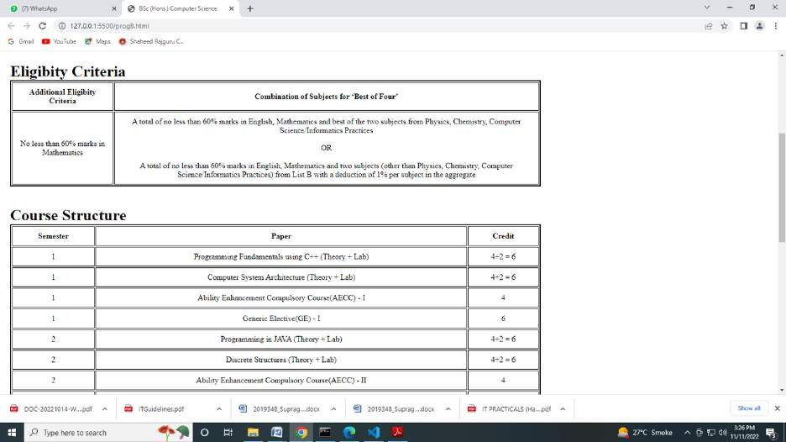

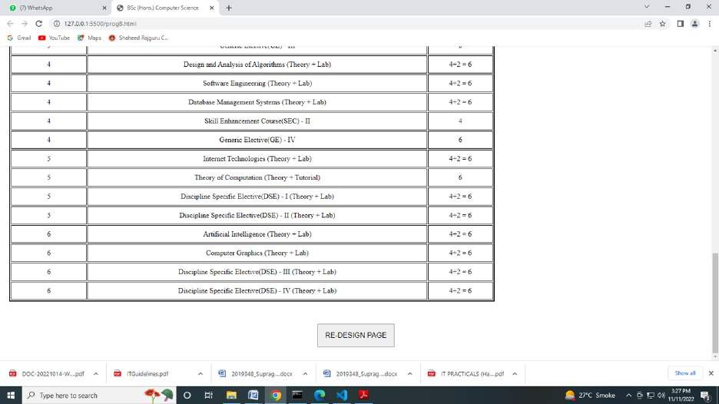

On clicking redesign



SHAHEED RAJGURU COLMGE OF APPLIED SCIENCES FOR WOMEN, UNNERSITY OF DELHI

About

rees



Eligibity Criteria

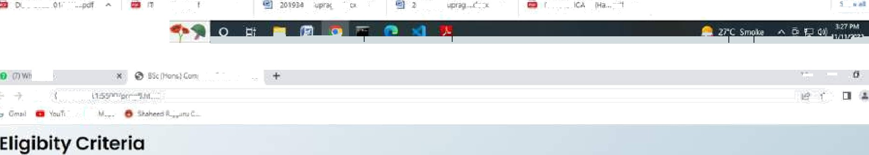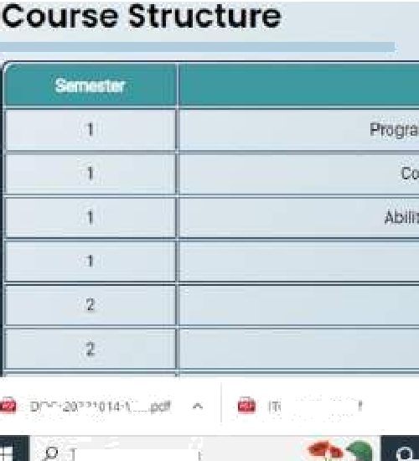

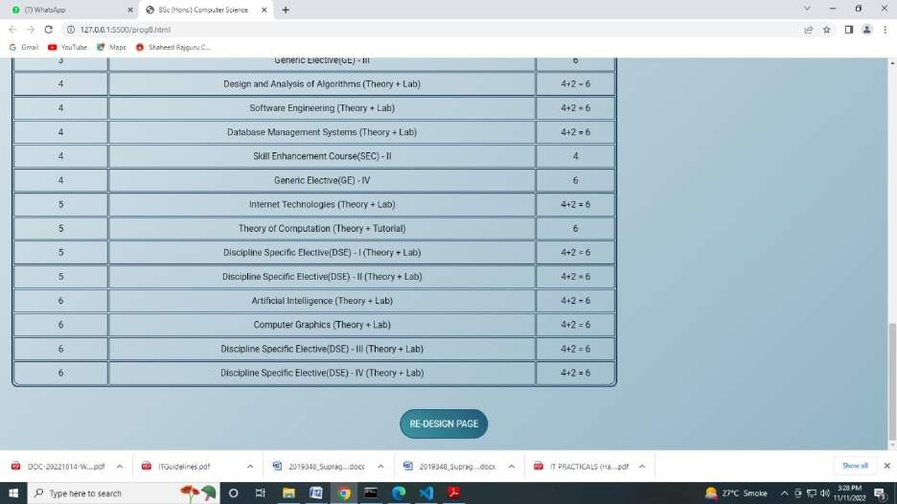

1. **Create an HTML page for an image gallery which shows the use of BOOTSTRAP to rearrange and resize its contents on resizing the browser.**

<!DOCTYPE html>

<html lang="en">

<head>

<title>IMAGE GALLERY</title>

<meta charset="utf-8">

<meta name="viewport" content="width=device-width, initial-scale=1">

<link href=["https://cdn.jsdelivr.net/npm/bootstrap@5.2.1/dist/css/bootstrap.min.css"](https://cdn.jsdelivr.net/npm/bootstrap%405.2.1/dist/css/bootstrap.min.css) rel="stylesheet">

<script src=["https://cdn.jsdelivr.net/npm/bootstrap@5.2.1/dist/js/bootstrap.bundle.min.js">](https://cdn.jsdelivr.net/npm/bootstrap%405.2.1/dist/js/bootstrap.bundle.min.js)</script>

<body>

<div class="container mt-5">

<div class="row">

<div class="col-sm-2"><img src="img/p1.jpg" width="150" height="150"></div>

<div class="col-sm-2"><img src="img/p2.jpg" width="150" height="150"></div>

<div class="col-sm-2"><img src="img/3.jpg" width="150" height="150"></div>

<div class="col-sm-2"><img src="img/p4.jpg" width="150" height="150"></div>

<div class="col-sm-2"><img src="img/p5.jpg" width="150" height="150"></div>

<div class="col-sm-2"><img src="img/6.jpg" width="150" height="150"></div>

</div>

<div class="row">

<div class="col-sm-2"><img src="img/9.jpg" width="150" height="150"></div>

<div class="col-sm-2"><img src="img/10.jpg" width="150" height="150"></div>

<div class="col-sm-2"><img src="img/12.jpg" width="150" height="150"></div>

<div class="col-sm-2"><img src="img/13.jpg" width="150" height="150"></div>

<div class="col-sm-2"><img src="img/14.jpg" width="150" height="150"></div>

<div class="col-sm-2"><img src="img/15.jpg" width="150" height="150"></div>

</div>

<div class="row">

<div class="col-sm-2"><img src="img/d.jpg" width="150" height="150"></div>

<div class="col-sm-2"><img src="img/e.jpg" width="150" height="150"></div>

<div class="col-sm-2"><img src="img/f.jpg" width="150" height="150"></div>

<div class="col-sm-2"><img src="img/g.jpg" width="150" height="150"></div>

<div class="col-sm-2"><img src="img/h.jpg" width="150" height="150"></div>

<div class="col-sm-2"><img src="img/v12.jpg" width="150" height="150"></div>

</div>

<div class="row">

<div class="col-sm-2"><img src="img/z1.jpg" width="150" height="150"></div>

<div class="col-sm-2"><img src="img/z2.jpg" width="150" height="150"></div>

<div class="col-sm-2"><img src="img/z3.jpg" width="150" height="150"></div>

<div class="col-sm-2"><img src="img/z4.jpg" width="150" height="150"></div>

<div class="col-sm-2"><img src="img/v13.jpg" width="150" height="150"></div>

<div class="col-sm-2"><img src="img/v14.jpg" width="150" height="150"></div>

</div>

<div class="row">

<div class="col-sm-2"><img src="img/v1.jpg" width="150" height="150"></div>

<div class="col-sm-2"><img src="img/v2.jpg" width="150" height="150"></div>

<div class="col-sm-2"><img src="img/v3.jpg" width="150" height="150"></div>

<div class="col-sm-2"><img src="img/v4.jpg" width="150" height="150"></div>

<div class="col-sm-2"><img src="img/v5.jpg" width="150" height="150"></div>

<div class="col-sm-4"><img src="img/v6.jpg" width="150" height="150"></div>

</div>

<div class="row">

<div class="col-sm-2"><img src="img/v7.jpg" width="150" height="150"></div>

<div class="col-sm-2"><img src="img/v8.jpg" width="150" height="150"></div>

<div class="col-sm-2"><img src="img/v9.jpg" width="150" height="150"></div>

<div class="col-sm-2"><img src="img/v10.jpg" width="150" height="150"></div>

<div class="col-sm-2"><img src="img/v11.jpg" width="150" height="150"></div>

<div class="col-sm-2"><img src="img/v12.jpg" width="150" height="150"></div>

</div>

</div>

</html>

Output

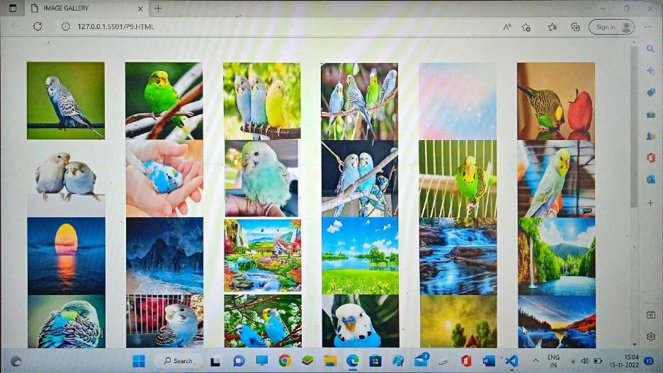

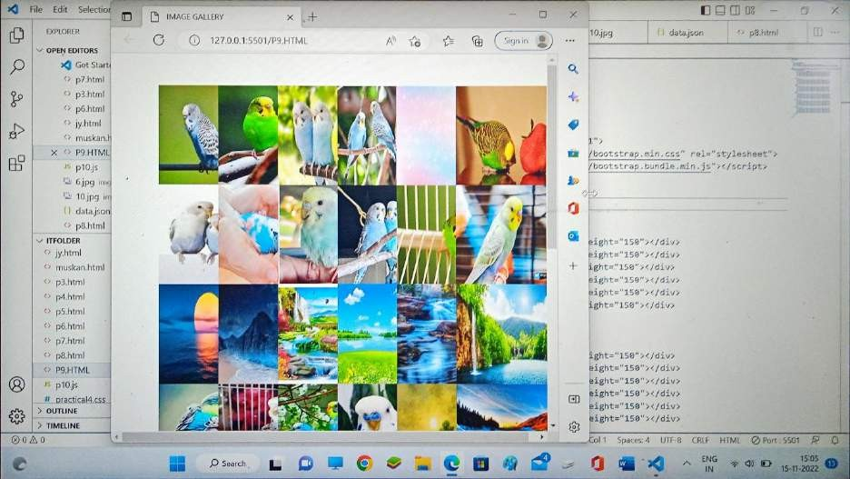

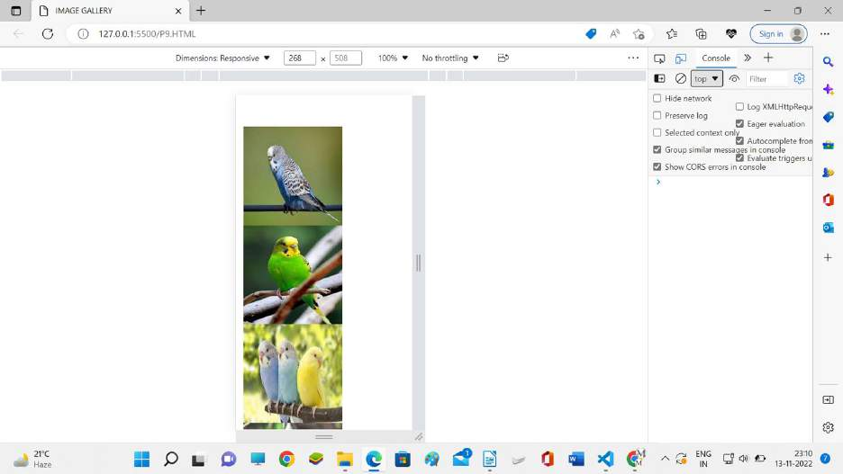

1. **Create an HTTP server using Node.js which handles requests on port 10000 or a free port beyond 10000. Modify the server in such a way that opening localhost:10000 will display “Hello world, This is my Node.js server” on browser.**

const http = require('http');

const findPort = require('find-free-port'); findPort(10000, function(err, freePort){

});

findPort(10000).then(([freep]) => { console.log('found ' + freep); server.listen(freep, () => {

console.log(`Server running at port ${freep}`)

});

}).catch((err)=>{

console.error(err);

});

const server = http.createServer((req, res) => { res.statusCode = 200 res.setHeader('Content-Type', 'text/html')

res.end('<h1>Hello World, This is my Node.js server</h1>')

})

**Output:**

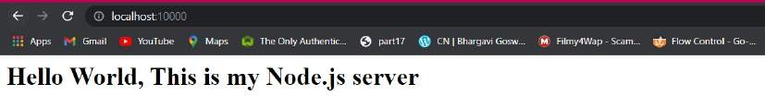

##### Create index.html file containing two forms for SignIn and SignUp. Submitting SignIn form should search for credentials in mysql database using server created in previous practical. On successful signin, a welcome page should be displayed. Submitting SignUp form should insert new entry for credentials in mysql database using server created in previous practical. On successful signup, user should be returned back to index.html.

Index.html

<!DOCTYPE html>

<html lang="en">

<head>

<meta charset="UTF-8">

<meta http-equiv="X-UA-Compatible" content="IE=edge">

<meta name="viewport" content="width=device-width, initial-scale=1.0">

<title>Document</title>

</head>

<body>

<h1><a href="showsignin">Sign-In</a></h1>

<h1><a href="showsignup">Sign-Up</a></h1>

</body>

</html>

Sign in html

<!DOCTYPE html>

<html lang="en">

<head>

<meta charset="UTF-8">

<meta http-equiv="X-UA-Compatible" content="IE=edge">

<meta name="viewport" content="width=device-width, initial-scale=1.0">

<title>Document</title>

</head>

<body>

<h1>Welcome to Sign-In Page</h1>

<form action="/dosignin" method="post">

<label for="username">Username</label>

<input type="text" name="username" id="" />

<br>

<label for="password">Password</label>

<input type="password" name="password" id="" />

<input type="submit" name="submit" id="" value="Sign-In" />

</form>

</body>

</html>

Sign up.html

<!DOCTYPE html>

<html lang="en">

<head>

<meta charset="UTF-8">

<meta http-equiv="X-UA-Compatible" content="IE=edge">

<meta name="viewport" content="width=device-width, initial-scale=1.0">

<title>Document</title>

</head>

<body>

<h1>Welcome to Sign-In Page</h1>

<form action="/dosignup" method="post">

<label for="username">Username</label>

<input type="text" name="username" id="" />

<br>

<label for="email">Email-id</label>

<input type="email" name="email" id="" />

<br>

<label for="password">Password</label>

<input type="password" name="password" id="" required/>

<br>

<label for="cnfrmpass">Confirm Password</label>

<input type="password" name="cnfrmpass" id="" required/>

<br>

<p>By creating an account you agree to our <a

href="#" style="color:dodgerblue">Terms & Privacy</a>.</p>

<input type="submit" name="submit" id="" value="Sign-Up" />

</form>

</body>

</html>

Server2.js

const http = require('http') const url = require('url') const fs = require('fs')

const mysql = require('mysql'); var qs = require('querystring'); const hostname = '127.0.0.1' const port = 3000

function onRequest(req, res) {

var baseURL = 'http://' + req.headers.host + '/'; var myURL = new URL(req.url, baseURL); res.statusCode = 200

res.setHeader('Content-Type', 'text/HTML') if (req.url == '/')

{

index(req, res)

}

else if (req.url == '/showsignin')

{

showsignin(req, res)

}

else if (req.url == '/showsignup')

{

showsignup(req, res)

}

else if (req.url == '/dosignin')

{

var body = '';

req.on('data', function (data)

{

body += data;

});

req.on('end', function ()

{

var post = qs.parse(body); dosignin(req, res, post)

});

}

else if (req.url == '/dosignup')

{

var body = '';

req.on('data', function (data)

{

body += data;

});

req.on('end', function ()

{

var post = qs.parse(body); dosignup(req, res, post)

});

}

else

{

res.end();

}

}

function dosignin(req, res, body)

{

var con = mysql.createConnection({ host: "127.0.0.1",

user: "root", password: "casw", database: "mydb"

});

con.connect(function (err)

{

var username = body.username; var password = body.password;

con.query("SELECT * FROM userlogin where username=? and password=?", [username, password], function (err, result, fields) { console.log(result);

if (err)

{

res.write("failed") res.end()

return;

};

if (result.length <= 0)

{

res.write('error'); res.end();

return;

}

else

{ // if user found res.write("Sign-In successful") res.end()

}

});

});

}

function dosignup(req, res, body) { var con = mysql.createConnection({ host: "127.0.0.1",

user: "root", password: "casw", database: "mydb"

});

con.connect(function (err) { var cnfrmpass= body.cnfrmpass inputData={

username: body.username, password: body.password

}

con.query("SELECT * FROM userlogin where username=?", [inputData.username], function (err, result, fields) {

console.log(result); if (err) { res.write("Failed") res.end()

};

if(result.length>0)

{

return;

res.write("Username Already Exist") res.end()

}

else if(cnfrmpass!=inputData.password){ res.write("Password & Confirm Password did not Match") res.end()

}

else

{

con.query("INSERT INTO userlogin SET ?", inputData, function (err, result, fields) {

console.log(result); if (err)

{

res.write("failed") res.end()

return;

};

res.write("Sign-Up successful") res.end()

});

}

});

});

}

function showsignin(req, res) { fs.readFile('signin.html', function (err, data) { res.write(data);

return res.end();

});

}

function showsignup(req, res) { fs.readFile('signup.html', function (err, data) { res.write(data);

return res.end();

});

}

function index(req, res) { fs.readFile('index.html', function (err, data) { res.write(data);

return res.end();

});

}

const server = http.createServer(onRequest) server.listen(port, hostname, () => {

console.log(`Server running at http://${hostname}:${port}/`)

})

Output Index.html

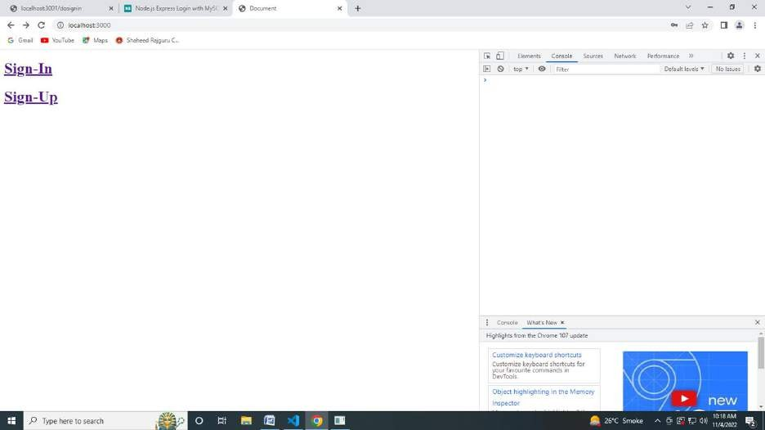

Sign in html

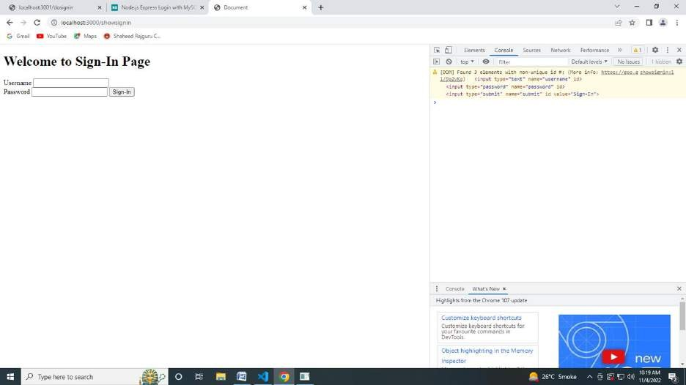

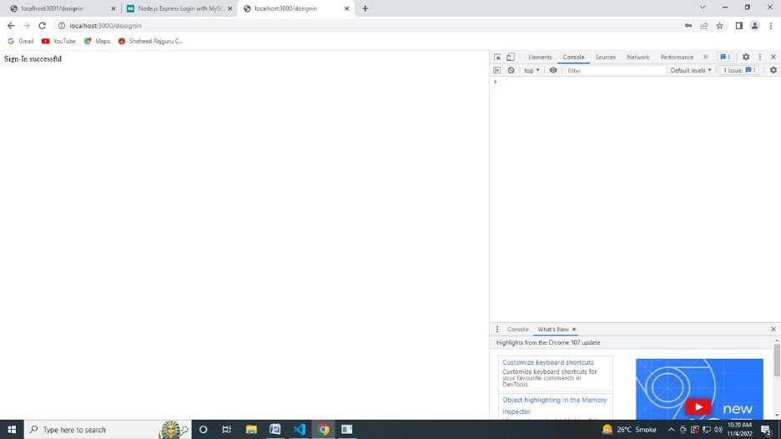

Onn wrong details

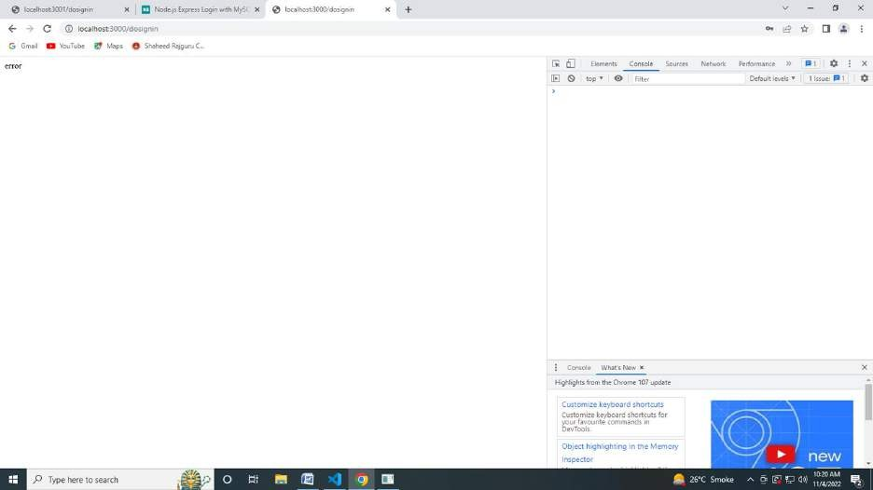

Sign up

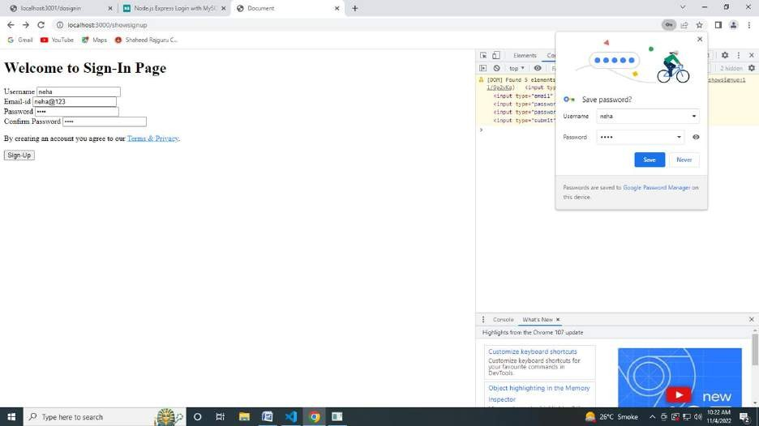

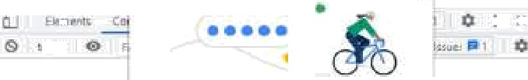  







Oaiabase charged

1 rove in sec t0.00 sec) cysql› describe userl gir;

F 1elJ

username .'arc ñar‹S0) *ES

MULL MULL

? rotas in see (B.00 sec )

cysql› select ’ frOc userlOgir;

j un‹

3 rotas in see (B.00 sec )

##### EXTRA QUESTIONS

**Q1 Design a responsive webpage displaying timetable as shown in reference images 1 and 2 using bootstrap**.

**code**

<!DOCTYPE html>

<html lang="en">

<head>

<title>Responsive Timetable</title>

<meta charset="utf-8">

<meta name="viewport" content="width=device-width, initial-scale=1">

<link href=["https://cdn.jsdelivr.net/npm/bootstrap@5.2.1/dist/css/bootstrap.min.cs](https://cdn.jsdelivr.net/npm/bootstrap%405.2.1/dist/css/bootstrap.min.css)s" rel="stylesheet">

<script src=["https://cdn.jsdelivr.net/npm/bootstrap@5.2.1/dist/js/boo](https://cdn.jsdelivr.net/npm/bootstrap%405.2.1/dist/js/bootstrap.bundle.min.js)t[strap.bundle.min.js](https://cdn.jsdelivr.net/npm/bootstrap%405.2.1/dist/js/bootstrap.bundle.min.js) "></script>

<body>

<div class="container mt-5">

<h1>TIME TABLE</h1>

<p>Resize the browser window to see effect</p>

<div class="row">

<div class="col-sm-2" style="background-color: rgb(211, 211, 211);">Monday</div>

<div class="col-sm-1">assembly</div>

<div class="col-sm-1">maths</div>

<div class="col-sm-1">english</div>

<div class="col-sm-1">short break</div>

<div class="col-sm-1">science</div>

<div class="col-sm-1">sports</div>

<div class="col-sm-1">hindi</div>

<div class="col-sm-1">lunch break</div>

<div class="col-sm-1">PAVA</div>

<div class="col-sm-1">library</div>

</div>

<br>

<div class="row">

<div class="col-sm-2" style="background-color: rgb(211, 211, 211);">Tuesday</div>

<div class="col-sm-1">assembly</div>

<div class="col-sm-1">english</div>

<div class="col-sm-1">sports</div>

<div class="col-sm-1">short break</div>

<div class="col-sm-1">social science</div>

<div class="col-sm-1">maths</div>

<div class="col-sm-1">third language</div>

<div class="col-sm-1">lunch break</div>

<div class="col-sm-1">hindi</div>

<div class="col-sm-1">science</div>

</div>

<br>

<div class="row">

<div class="col-sm-2" style="background-color: rgb(211, 211, 211);">Wednesday</div>

<div class="col-sm-1">assembly</div>

<div class="col-sm-1">science</div>

<div class="col-sm-1">english</div>

<div class="col-sm-1">short break</div>

<div class="col-sm-1">social science</div>

<div class="col-sm-1">maths</div>

<div class="col-sm-1">computer lab</div>

<div class="col-sm-1">lunch break</div>

<div class="col-sm-1">hindi</div>

<div class="col-sm-1">QCT</div>

</div>

<br>

<div class="row">

<div class="col-sm-2" style="background-color: rgb(211, 211, 211);">Thursday</div>

<div class="col-sm-1">assembly</div>

<div class="col-sm-1">social science</div>

<div class="col-sm-1">english</div>

<div class="col-sm-1">short break</div>

<div class="col-sm-1">science</div>

<div class="col-sm-1">maths</div>

<div class="col-sm-1">computer lab</div>

<div class="col-sm-1">lunch break</div>

<div class="col-sm-1">third language</div>

<div class="col-sm-1">hindi</div>

</div>

<br>

<div class="row">

<div class="col-sm-2" style="background-color: rgb(211, 211, 211);">Friday</div>

<div class="col-sm-1">assembly</div>

<div class="col-sm-1">science</div>

<div class="col-sm-1">english</div>

<div class="col-sm-1">short break</div>

<div class="col-sm-1">vocational skills</div>

<div class="col-sm-1">maths</div>

<div class="col-sm-1">design</div>

<div class="col-sm-1">lunch break</div>

<div class="col-sm-1">PAVA</div>

<div class="col-sm-1">Closure</div>

</div>

<br>

</div>

</html>

##### Output





TIME TABLE

Pesize the browser window to see etfe‹i



|  |  |  |  |  |  |  |  |  |  |  |
| --- | --- | --- | --- | --- | --- | --- | --- | --- | --- | --- |
|  | | | | bfeak |  |  |  | break |  | |
| .Tiesday | asssmd Iy | english | sports | short break | $OCi | maths | th'rd language | wincn break' | hindi | science |
| !Wédnésd6y.' | assemfii Iy' | science | englis h | short  break | sora science |  | connpufri’  ta0 | |umch  b-ebk | hindi | QCT |
|  |  | soc ial  science | english | short break | scienc e | maths | computer | IunEfi | tIs‹M  IangcJage | hindi |
| F•ridsj.. | assem L' Iy | science | englis h | short  breaL | vocational | mat Us | design | IunEh b’eaL | PAVA |  |





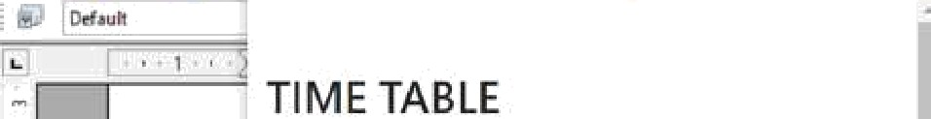

Resize the browser window to see effect 

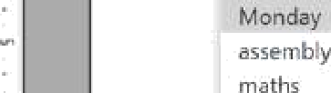   



m lu nch break

Tz ”Tu y' 

asse n-:b y

- english

short bieak



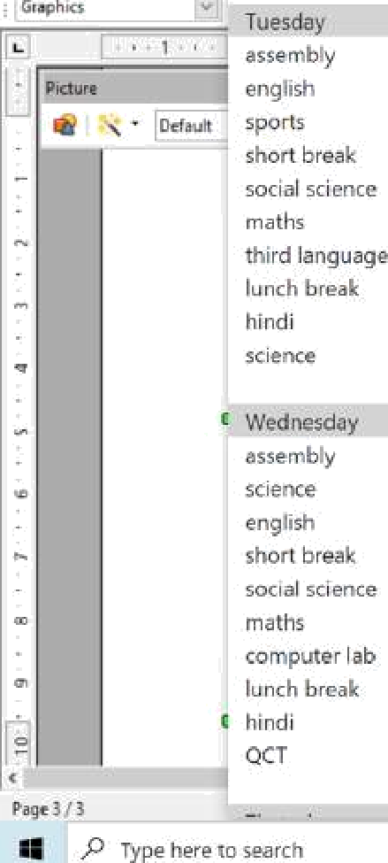 















short break

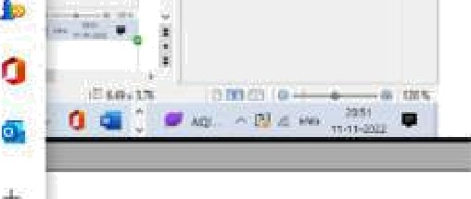socidl icier ce maths computer lab lunch break hindi

'’ lhuoday, 

_ assemb-y

english shot braaA

- science



lunch' br-eak II'.ird lai guaqe hindi





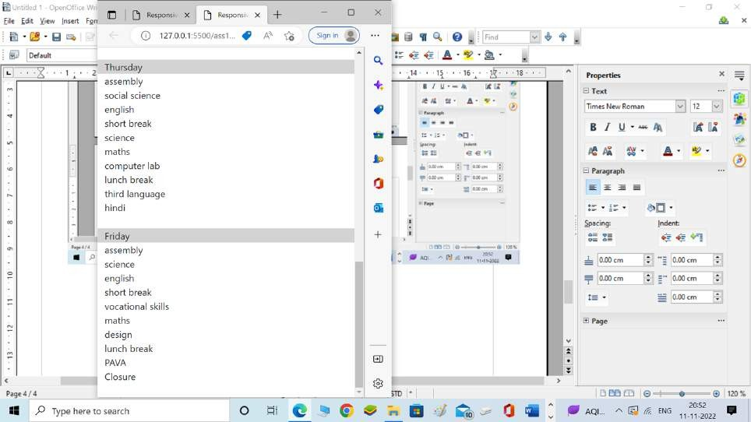

**Q2 Design a webpage displaying a restaurant's menu with image of food item along with price and item name. On smaller devices only name and price should display.**

##### Code

<!DOCTYPE html>

<html lang="en">

<head>

<title>Responsive Timetable</title>

<meta charset="utf-8">

<meta name="viewport" content="width=device-width, initial-scale=1">

<link href=["https://cdn.jsdelivr.net/npm/bootstrap@5.2.1/dist/css/bootstrap.min.cs](https://cdn.jsdelivr.net/npm/bootstrap%405.2.1/dist/css/bootstrap.min.css)s" rel="stylesheet">

<script src=["https://cdn.jsdelivr.net/npm/bootstrap@5.2.1/dist/js/bootstrap.bundle.min.js](https://cdn.jsdelivr.net/npm/bootstrap%405.2.1/dist/js/bootstrap.bundle.min.js) "></script>

<style> body{

background-image: url('foods/rest.jpg'); background-repeat: no-repeat;

background-size: 100% 100%; background-attachment: fixed;

}

</style>

</head>

<body>

<div class="container mt-5">

<h1 style="color: white;">Restaurent Menu</h1>

<div class="row">

<div class="col-sm-4 d-none d-md-block"><img src="foods/aobhaji.jpg"></div>

<div class="col-sm-4" style="color: white;">Pao Bhaji</div>

<div class="col-sm-4" style="color: white;">40</div>

</div>

<br>

<div class="row">

<div class="col-sm-4 d-none d-md-block"><img src="foods/dosa.jpg"></div>

<div class="col-sm-4" style="color: white;">Dosa</div>

<div class="col-sm-4" style="color: white;">60</div>

</div>

<br>

<div class="row">

<div class="col-sm-4 d-none d-md-block"><img src="foods/friedrice.jpg"></div>

<div class="col-sm-4" style="color: white;">Fried Rice</div>

<div class="col-sm-4" style="color: white;">55</div>

</div>

<br>

<div class="row">

<div class="col-sm-4 d-none d-md-block"><img src="foods/ggi.jpg"></div>

<div class="col-sm-4" style="color: white;">Maggi</div>

<div class="col-sm-4" style="color: white;">35</div>

</div>

<br>

<div class="row">

<div class="col-sm-4 d-none d-md-block"><img src="foods/ha.jpg"></div>

<div class="col-sm-4" style="color: white;">Poha</div>

<div class="col-sm-4" style="color: white;">80</div>

</div>

<br>

<div class="row">

<div class="col-sm-4 d-none d-md-block"><img src="foods/howmine.jpg"></div>

<div class="col-sm-4" style="color: white;">Chowmine</div>

<div class="col-sm-4" style="color: white;">45</div>

</div>

<br>

<div class="row">

<div class="col-sm-4 d-none d-md-block"><img src="foods/idli.jpg"></div>

<div class="col-sm-4" style="color: white;">Idli Sambhar</div>

<div class="col-sm-4" style="color: white;">35</div>

</div>

<br>

<div class="row">

<div class="col-sm-4 d-none d-md-block"><img src="foods/izza.jpg"></div>

<div class="col-sm-4" style="color: white;">Pizza</div>

<div class="col-sm-4" style="color: white;">99</div>

</div>

<br>

<div class="row">

<div class="col-sm-4 d-none d-md-block"><img src="foods/nchurian.jpg"></div>

<div class="col-sm-4" style="color: white;">Manchurian</div>

<div class="col-sm-4" style="color: white;">50</div>

</div>

<br>

<div class="row">

<div class="col-sm-4 d-none d-md-block"><img src="foods/pasta.jpg"></div>

<div class="col-sm-4" style="color: white;">Pasta</div>

<div class="col-sm-4" style="color: white;">50</div>

</div>

<br>

<div class="row">

<div class="col-sm-4 d-none d-md-block"><img src="foods/samosa.jpg"></div>

<div class="col-sm-4" style="color: white;">Samosa</div>

<div class="col-sm-4" style="color: white;">25</div>

</div>

<br>

<div class="row">

<div class="col-sm-4 d-none d-md-block"><img src="foods/urger.jpg"></div>

<div class="col-sm-4" style="color: white;">Burger</div>

<div class="col-sm-4" style="color: white;">45</div>

</div>

<br>

</div>

</html>

## Output

##### Restrauent nenu on big screen

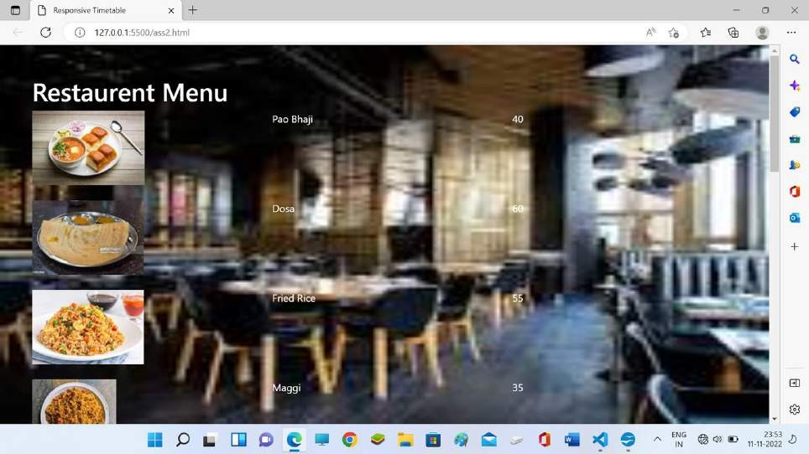

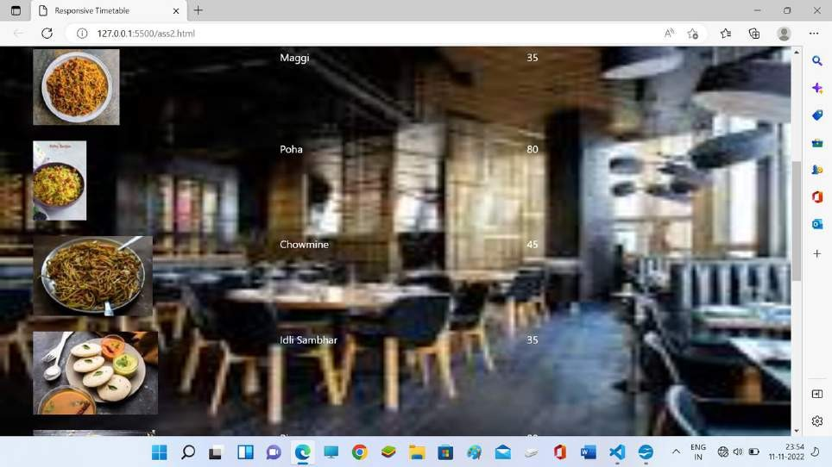

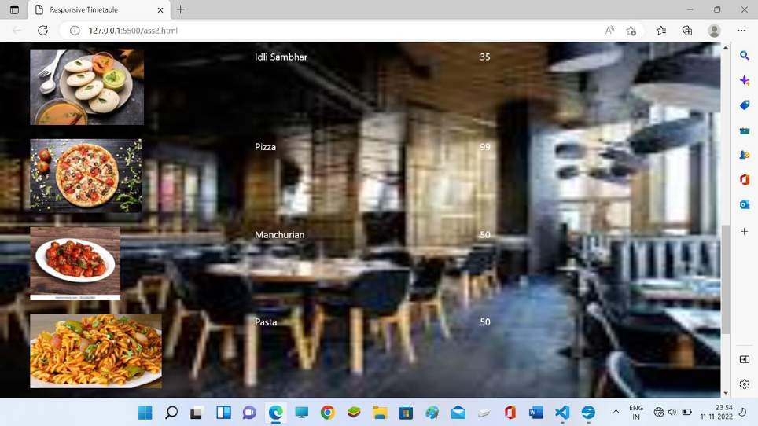

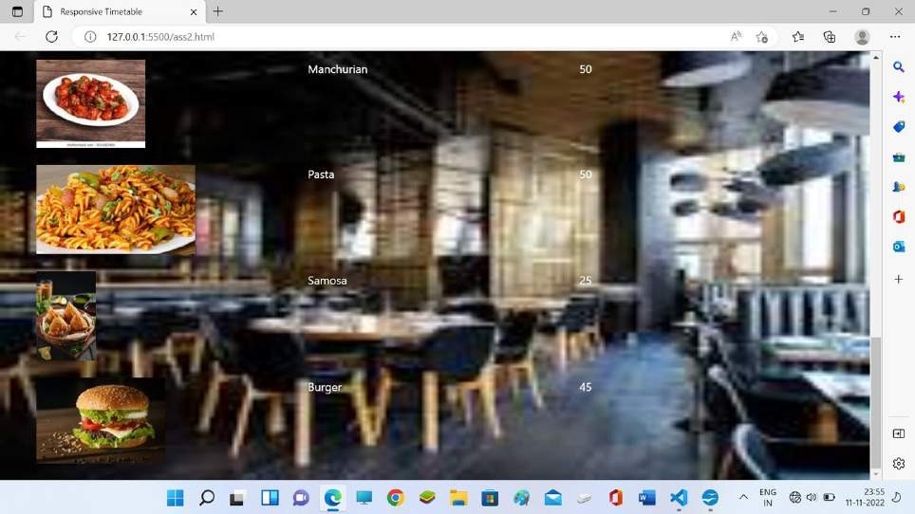

**Restrauent menu on smaller devices**



 

II

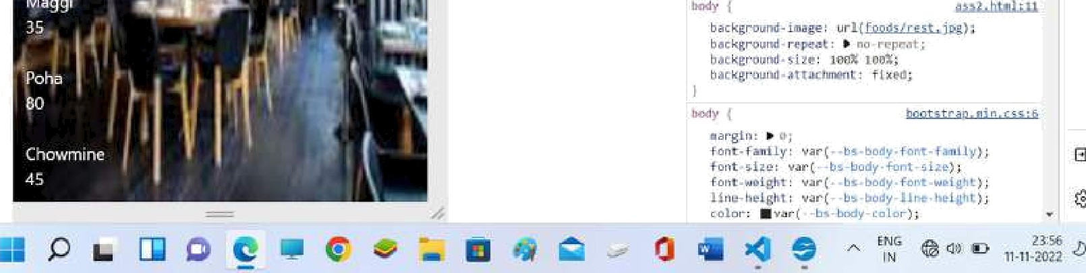



 

### II

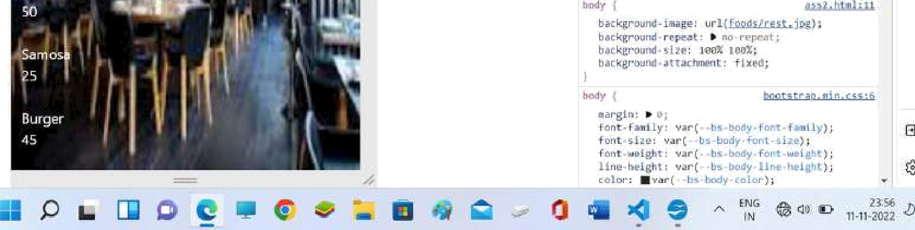

**Q3 form validation**

<!DOCTYPE html>

<html>

<head>

<style>

label, input, button {

border: 0;

margin-bottom: 3px; display: block; width: 100%;

}

.common_box_body { padding: 15px;

border: 12px solid #28BAA2; border-color: #28BAA2; border-radius: 15px; margin-top: 10px; background: #d4edda;

}

</style>

</head>

<body>

<div class="common_box_body test">

<h2> User Registration</h2>

<form action="#" name="registration" id="registration">

<label for="Name">Name</label>

<input type="text" name="array[]" id="name" placeholder="Meenakshi"><br>

<label for="Password">Password</label>

<input type="text" name="array[]" id="pass" placeholder="xxxxxx"><br>

Select Gender: <br>

<input type="checkbox" id="gender" name="Male" value="Male">

<label for="g1">Male<label><br>

<input type="checkbox" id="gender" name="Female" value="Female">

<label for="g2"> Female</label><br>

<input type="checkbox" id="gender" name="others" value="others">

<label for="g3"> Others</label><br>

<button type="button" id="submit" name="button"> Submit

</button>

</form>

<br>

</div>

<script src="jquery-3.6.1.min.js"></script>

<script>

$(document).ready(function () {

$("#submit").click(function () { name = $("#name").val();

if(name==""){alert("Username can't be blank");};

pass = $("#pass").val();

if(pass.length<6){alert("Password must have 6 characters");}; const gender = [];

$("input[type=checkbox]:checked").each(function () { gender.push($(this).val());

});

if(gender==false){alert("Gender must be selected");}; function user(name, pass,gender) {

this.name = name; this.pass = pass; this.gender = gender;

:"+gender);

});

}

var u1 = new user(name, pass,gender); console.log(u1);

alert("Name : " + name +"\nPassword :"+pass+"\nGender

});

</script>

<script src="jquery-3.6.1.min.js"></script>

</body>

</html>

**OUTPUT**

**Username validation**

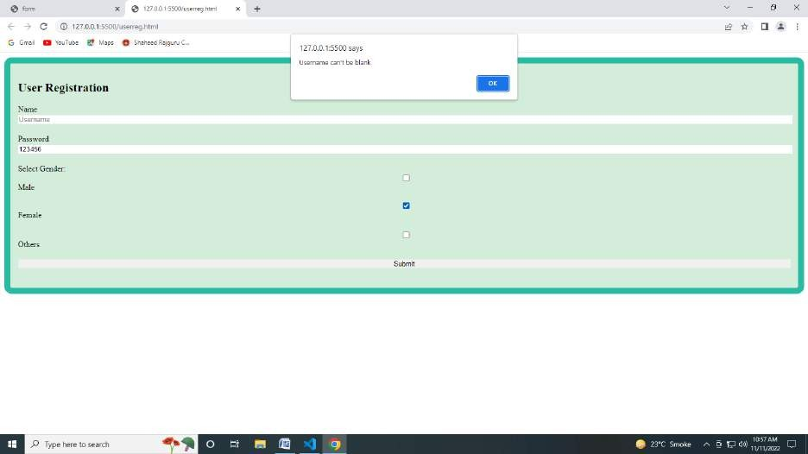

**Password validation**

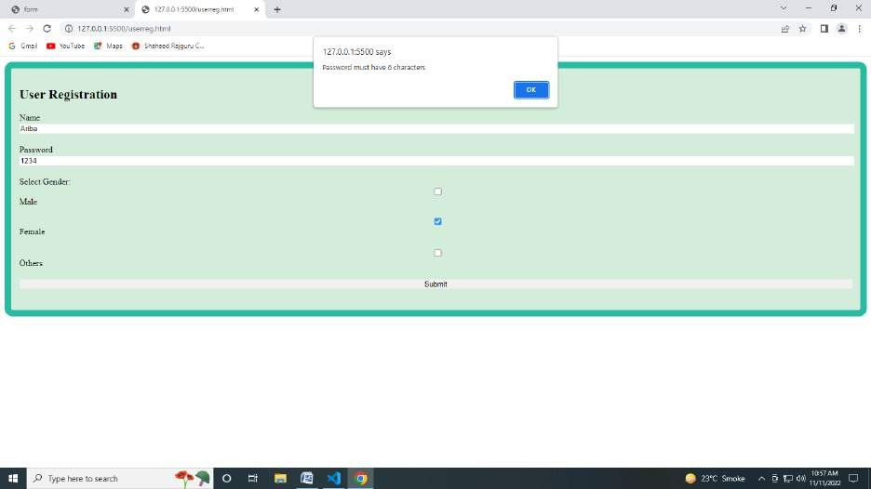

**Gender validation**

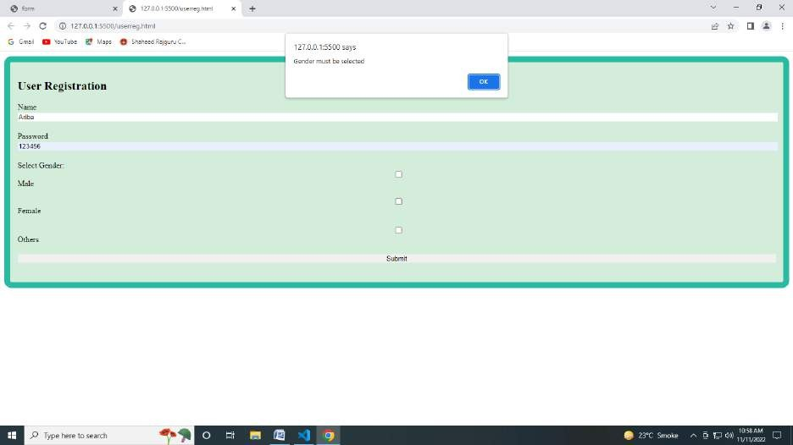

**Console output and alert**

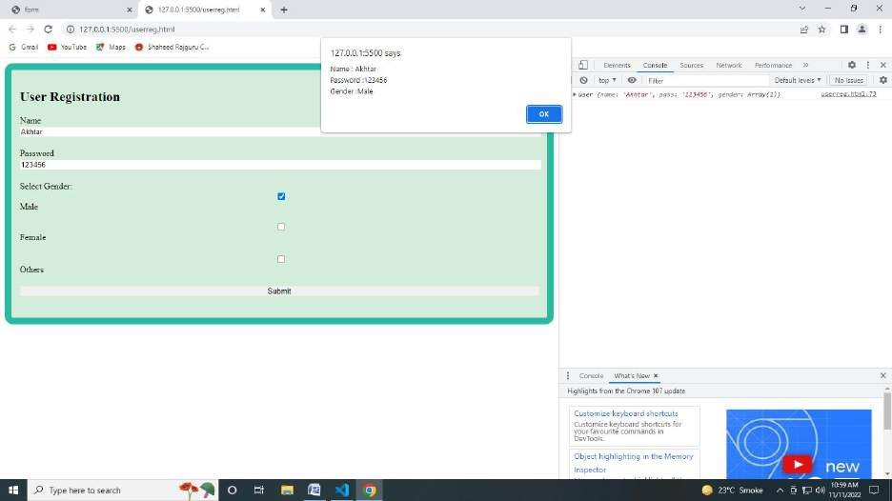

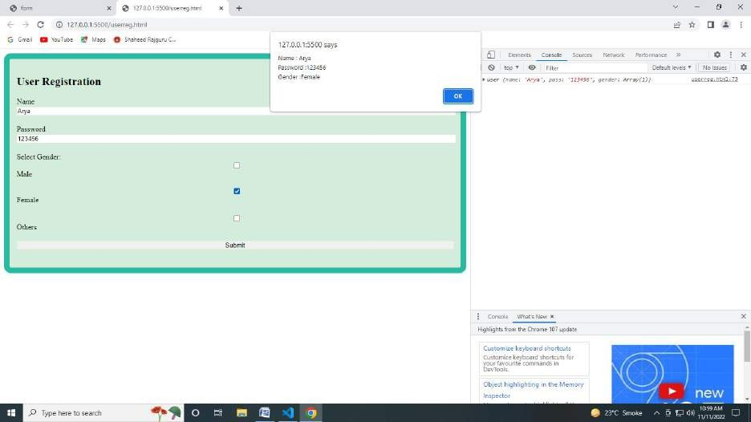

**Q.4 BootStrap Program**

**Code**

**<!DOCTYPE html>**

**<html lang="en">**

**<head>**

**<title>Bootstrap Program</title>**

**<meta charset="utf-8">**

**<meta name="viewport" content="width=device-width, initial-scale=1">**

**<link hr**[**ef="h**](https://cdn.jsdelivr.net/npm/bootstrap%405.2.1/dist/css/bootstrap.min.css)**ttp**[**s://cdn.jsdelivr.net/npm/bootstrap@5.2.1/dist/css/bootstrap.min.css**](https://cdn.jsdelivr.net/npm/bootstrap%405.2.1/dist/css/bootstrap.min.css)**" rel="stylesheet">**

**<script src**[**="https**](https://cdn.jsdelivr.net/npm/bootstrap%405.2.1/dist/js/bootstrap.bundle.min.js)**:/**[**/cdn.jsdelivr.net/npm/bootstrap@5.2.1/dist/js/bootstrap.bundle.min.js**](https://cdn.jsdelivr.net/npm/bootstrap%405.2.1/dist/js/bootstrap.bundle.min.js)**"></script>**

**</head>**

**<body>**

**<div class="container mt-5">**

**<h1>Four equal width column using container </h1>**

**<p>BOOTSTRAP EFFECT!!!!</p>**

**<div class="row">**

**<div class="col-sm-3 bg-primary text-white">.col</div>**

**<div class="col-sm-3 bg-dark text-white">.col</div>**

**<div class="col-sm-3 bg-primary text-white">.col</div>**

**<div class="col-sm-3 bg-dark text-white">.col</div>**

**</div>**

**</div>**

**<div class="container-fluid mt-5">**

**<h1>Four equal width column using container fluid</h1>**

**<p>BOOTSTRAP EFFECT!!!!</p>**

**<div class="row">**

**<div class="col-sm-3 bg-primary text-white">.col</div>**

**<div class="col-sm-3 bg-dark text-white">.col</div>**

**<div class="col-sm-3 bg-primary text-white">.col</div>**

**<div class="col-sm-3 bg-dark text-white">.col</div>**

**</div>**

**</div>**

**<div class="container mt-5">**

**<h1>Four equal diiferent column using container </h1>**

**<p>BOOTSTRAP EFFECT!!!!</p>**

**<div class="row">**

**<div class="col-sm-4 bg-primary text-white">.col</div>**

**<div class="col-sm-8 bg-dark text-white">.col</div>**

**<div class="col-sm-11 bg-primary text-white">.col</div>**

**<div class="col bg-dark text-white">auto</div>**

**</div>**

**</div>**

**<div class="container mt-5">**

**<h1>Different sizes with more than one size properties of column using container </h1>**

**<p>BOOTSTRAP EFFECT!!!!</p>**

**<div class="row">**

**<div class="col-sm-3 col-lg-8 bg-primary text-white">.col</div>**

**<div class="col-md-3 col-lg-8 bg-dark text-white">.col</div>**

**<div class="col-sm-2 bg-primary text-white">.col</div>**

**<div class="col-md-3 bg-dark text-white">.col</div>**

**</div>**

**</div>**

**</body>**

**</html>**

**Output**

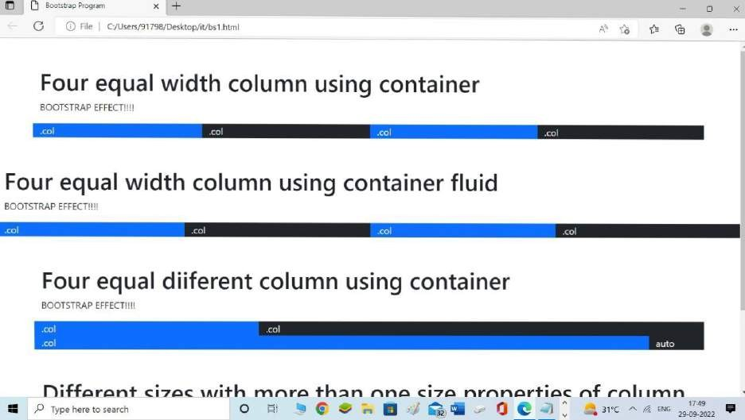

**Q5 CREATE A JAVASCRIPT PROGRAM TO TAKE BIRHDAY INPUT FROM USER**

**AND PRINT OUTPUT LIKE THIS: “Your Birthday Was on day” on screen.**

**HTML CODE**

<!Doctype html>

<html>

<head>

<style> body{

background-image: url('https://encrypted- tbn0.gstatic.com/images?q=tbn:ANd9GcSQAxK92Q5Ql0CuUt9wQCeAfaLOSuf9PQ8KJA&usqp=CAU');

background-repeat: no-repeat; background-attachment: fixed; background-size: cover;

}</style>

<title>Birthday webpage :)</title>

</head>

<body>

<h1 style=text-align:center>Enter your Birthdate:<br><br>

<input type="date" id="message" placeholder="p1" name="" ><br><br></h1>

<p style=text-align:center><input type="button" id="bt" value="DONE" onClick="setlabel()"/></p>

<h2 style=text-align:center>Your birthday is on :)

<label id="l1">N/A</label>

<label id="l2"> DAY</label></h2>

</ body>

<script>

function setlabel(){

let lbl=document.getElementById('l1'); let ab1=document.getElementById('l2');

let d1=document.getElementById('message').value; var d2=new Date(d1);

day=d2.getDay(); var d3; switch(day){

case 1:d3="Monday"; break;

case 2:d3="Tuesday"; break;

case 3:d3="Wednesday";

break;

case 4:d3="Thursday"; break;

case 5:d3="Friday"; break;

case 6:d3="saturday"; break;

case 0:d3="Sunday"; break;

}

lbl.innerText=d1; ab1.innerText=d3;

}

</script>

</ html >

**OUTPUT**

**INITIALLY**

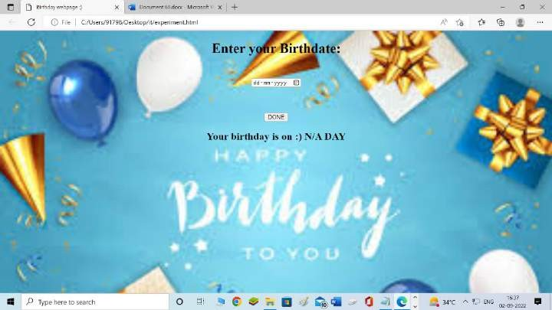

**ON SELECTING DATE**

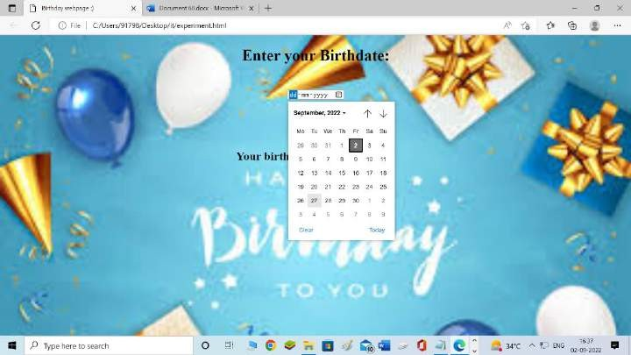

**ON CLICKING DONE BUTTON**

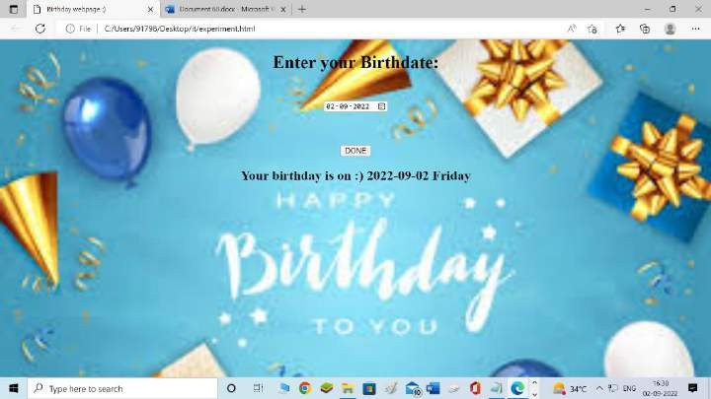

**Q6 DISPLAY A TIMER ON SCREEN THAT KEEPS ON UPDATING TIME EVERY SECOND.**

**HTML CODE**

<!Doctype html>

<html>

<head>

<style> body{

background-image: url('https://cdn.xxl.thumbs.canstockphoto.com/abstract-scene-current-time- picture_csp2652107.jpg');

background-repeat: no-repeat; background-attachment: fixed; background-size: cover;

}</style><title>Timer </title></head>

<body>

<h1 style=text-align:center>LIVE UPDATING TIMER:</h1><br><br>

<h2><p style=text-align:center id="a1"></p></h2>

<script> setInterval(time,1000); function time(){

const date=new Date(); document.getElementById("a1").innerHTML=date.toLocaleTimeString();

}

</script>

</body>

</ html >

**OUTPUT**

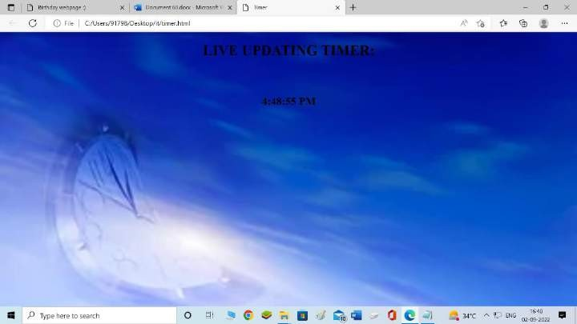

**Q7 STUDENT REGISTRATION FORM**

<!DOCTYPE html>

<html>

<head>

<style>

label, input, button {

border: 0;

margin-bottom: 3px; display: block; width: 100%;

}

.common_box_body { padding: 15px;

border: 12px solid #28BAA2; border-color: #28BAA2; border-radius: 15px; margin-top: 10px; background: #d4edda;

}

</style>

</head>

<body>

<div class="common_box_body test">

<h2>Registration</h2>

<h3 id="po">Input Array Elements</h3>

<form action="#" name="registration" id="registration">

<label for="firstname">First Name</label>

<input type="text" name="array[]" id="firstname" placeholder="John"><br>

<label for="lastname">Last Name</label>

<input type="text" name="array[]" id="lastname" placeholder="Doe"><br>

<label for="email">Email</label>

<input type="email" name="array[]" id="email" placeholder="[john@doe.com](mailto:john@doe.com)"><br>

<label for="password">Password</label>

<input type="password" name="array[]" id="password" placeholder=""><br>

Select subject(s): <br>

<input type="checkbox" id="Course1" name="physics" value="PHYSICS">

<label for="Course1">Physics<label><br>

<input type="checkbox" id="Course2" name="chemistry"

value="CHEMISTRY">

<label for="Course2"> chemistry</label><br>

<input type="checkbox" id="Course3" name="mathematics"

value="MATHEMATICS">

<label for="Course3"> Mathematics</label><br> s<button type="button" id="submit" name="button">

Submit

</button>

</form>

<br>

<p id="par"></p>

</div>

<script src="jquery-3.6.1.min.js"></script>

<script>

$(document).ready(function () {

$("#submit").click(function () { firname = $("#firstname").val(); lasname = $("#lastname").val(); pass = $("#password").val();

emaid = $("#email").val(); const courses = [];

$("input[type=checkbox]:checked").each(function () { courses.push($(this).val());

});

function Student(fname, lname, pass, eid, courses) { this.fname = firname;

this.lname = lasname; this.pass = pass; this.eid = emaid; this.courses = courses;

courses);

});

});

}

var student1 = new Student(firname, lasname, pass, emaid, console.log(student1)

</script>

<script src="jquery-3.6.1.min.js"></script>

</body>

</html>

